VINCENTIAN REFLECTIONS

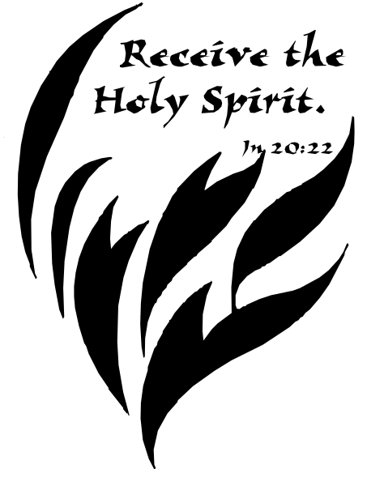

Fourth Quarter-2019

Liturgical Year: Cycle C
October
November
Liturgical Year: Cycle A
December

Available on WWW.SVDPUSA.ORG (Spiritual Resources)



HOW TO LEAD THE VINCENTIAN REFLECTIONS IN A CONFERENCE

INTRODUCTION:
Leader describes to the group the process which is going to take place:
- Provide a copy for each member of your Conference for their personal reflection
- Stress that sharing is not compulsory and mention the need for confidentiality
- Ask, or assign, different members to read the different sections:
-Gospel reading
-Reflection
-Vincentian Meditation

OPENING PRAYER/QUIETING DOWN PERIOD
Leader invites group to:
- Become relaxed and aware of God’s presence with us
- “Let Go” of distractions and quietly pray to the Holy Spirit

READING OF THE VINCENTIAN WEEKLY REFLECTION
- Each section is read aloud, slowly and prayerfully, by the different members
- Hearing different voices will allow different emphasis on words/phrases

QUIET PERIOD
Leader invites everyone:
- To quietly reflect on the readings and notice if anything strikes them
- Introduces the Discussion Question suggested in the Reflection
- Allows 2-3 minutes of quiet

SHARING
Leader invites members who wish to share on the Discussion Question, or on how
the one of the readings struck them. Possibly not everyone will share, but time should be allowed for each person who wishes to share his/her thoughts.

CLOSING PRAYER
Leader closes the Prayer Reflection by beginning the Closing Prayer, and all answer the response(in bold).

(This entire process should take about 10-15 minutes)
INTRODUCTION:
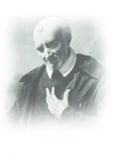

St. Vincent de Paul never wrote a book about his spiritual
teachings. But we find the living voice of the saint in his
letters and conferences in which he trained his followers
for the mission of service to the poor.

The two fundamental sources of his teaching are the GOSPEL
and LIFE. He wanted his followers to put the whole of the
Gospel into the whole of their lives, and he never wearied of
deepening both with all the faith that God had put into his heart.
That is why all that Vincent says to us has the simplicity of our
everyday life and the penetrating strength of the Word of God.

The Vincentian Weekly Reflections are therefore offered to all
who strive to serve the poor in the spirit of St. Vincent de Paul.
The prayer and reflections are based on the Sunday Gospel of the
Liturgical Calendar, together with the feast days of some of the
saints of our Vincentian Family. Each reflection offers a time
for prayer, silence and discussion so that our everyday life,
like Vincent, can become penetrated with the strength of the
Word of God.

Provided by:
Sister Kieran Kneaves, DC Society of St. Vincent de Paul, USA National Vincentian Formation Director

You may want to run copies for each member of your Conference so
that they may take them home for personal reflection during the week.

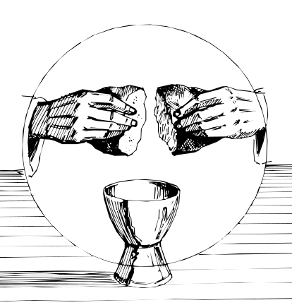

LITURGICAL CHURCH
2019

OCTOBER—Year C

October 6, 2019 Twenty-seventh Sunday of Ordinary Time
October 13, 2019 Twenty-eight Sunday of Ordinary Time
October 20, 2019 Twenty-ninth Sunday of Ordinary Time
October 27, 2019 Thirtieth Sunday of Ordinary Time

NOVEMBER

November 1 All Saints
November 2 Commemoration of All the Faithful Departed
November 3, 2019 Thirty-first Sunday of Ordinary Time
November 10, 2019 Thirty-second Sunday of Ordinary Time
November 17, 2019 Thirty-third Sunday in Ordinary Time November 24, 2019 Christ the King
November 27 Feast of the Miraculous Medal
November 28 Feast of St. Catherine Laboure

DECEMBER-Cycle A

December 1, 2019 First Sunday of Advent
December 8, 2019 Second Sunday of Advent
December 9 ,2019 The Feast of the Immaculate Conception
December 15, 2019 Third Sunday of Advent
December 22, 2019 Fourth Sunday of Advent
December 25 Christmas
December 29, 2019 Holy Family

TWENTY-SEVENTH SUNDAY IN ORDINARY TIME
October 6, 2019

Gospel: (Luke 17:5-10)
The apostles said to the Lord, “Increase our faith.” The Lord replied, “…Who among you would say to your servant who has just come in from plowing or tending the sheep in the field, ‘Come here immediately and take your place at table’? Would he not rather say to him, ‘Prepare something for me to eat. Put on your apron and wait on me while I eat and drink. You may eat and drink when I am finished’? Is he grateful to that servant because he did what was commanded? So should it be with you. When you have done all you have been commanded, say, ‘We are unprofitable servants; we have done what we were obliged to do.”

Reflection:
The apostles’ request of Jesus to “increase (their) faith” is made in the face of the seemingly impossible demands of discipleship. Jesus answers by illustrating what faithful discipleship looks like. The servant has been laboring all day in the field, but more is yet to be done. The work of the disciples is never completed. Discipleship is never-ending. To be a disciple means to be a servant. Here faith means faithfulness, that is, faithfulness in service. The faith-filled person puts in an honest day’s work. That person is gracious to those with whom he or she comes in contact. That person is ready to reach out and help another, even beyond one’s own work load. That person does not judge or condemn others. The faith-filled person sees Jesus in the other and responds to the situation with Jesus’ love and mercy. Faith is faithfulness in action. (Living Liturgy, p.220)

Vincentian Meditation:
We are called to be servants of the poor. And, mercy, says Vincent, is the “proper attribute of God himself.” Mercy is a facet of charity that calls us, first to identify in spirit with the other person. For instance, St.Vincent tells us, “To be compassionate toward the sufferings of our neighbor and to weep with him…to soften our hearts and to render them responsive to their sufferings and miseries.” Indeed, “love gains for us an entrance into the hearts of others.” Mercy calls as well for outward signs or gestures. As St. Vincent observed, “Heart and hand should go together as far as possible.” Consequently, he urges, “Weep with your poor and your sick. God has appointed you to be their consolation…Serve the poor with gentleness, compassion and love.”
(Melito, St. Vincent de Paul “Windows on His Vision”, p. 139)

Discussion: (Share your thoughts after a moment of silence)

Is our Vincentian service filled with mercy, where heart and hand go together?
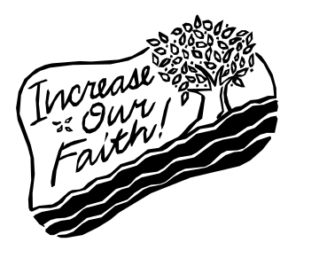
Closing Prayer:

Lord, increase our faith,
-give us compassionate hearts filled with mercy.
Lord, give us the grace to weep with those we serve,
-forgive us the times when we judged or condemned them.
Lord, may we bring consolation to those who are suffering,
-may our heart and hand always go together. Amen

TWENTY-EIGHTH SUNDAY IN ORDINARY TIME
October 13, 2019

Gospel: (Luke 17:11-19)
As Jesus was entering a village, ten lepers met him. They stood at a distance from him and raised their voices, saying, “Jesus, Master! Have pity on us!” And when he saw them, he said, “Go show yourselves to the priests.” As they were going they were cleansed. And one of them, realizing he had been healed, returned, glorifying God in a loud voice; and he fell at the feet of Jesus and thanked him. He was a Samaritan. Jesus said in reply, “Ten were cleansed, were they not? Where are the other nine? Has none but this foreigner returned to give thanks to God?” Then he said to him, “Stand up and go; your faith has saved you.”

Reflection:
Gratitude is an expression of discipleship and a sign of God’s reign. This gospel presents a foreign leper who asks for healing, obeys what is commanded, experiences healing, and then gives thanks to God. The faith that saves is the recognition that God acts in many ways on our behalf to bring us salvation. We are healed each time we come to Eucharist to give praise and thanks to God and in this act of worship we become more perfect members of the body of Christ. We are healed each time we put others ahead of ourselves and in these simple acts we strengthen our faith. We are healed each time we pause to “give thanks to God” for the many blessings of each day because by giving thanks to God we acknowledge that God has acted in Christ. By giving thanks we acknowledge our own indebtedness—we are poor and everything we are and are becoming is because God has raised us up. (Living Liturgy, p. 224)

Vincentian Meditation:
If we have a grateful heart, we will see everything as gifts of God. There is a beautiful prayer of St. Thomas More who, when he was rich and enjoyed much favor from King Henry VIII, always kept his heart detached from the things of life. The prayer goes:
“Thanks be to You, Lord Jesus Christ, for all that you have given me.
Thanks be to You, Lord Jesus Christ, for all that you have taken away from me.
Thanks be to You, Lord Jesus Christ, for all that You have left me.”
May God give us the grace to be grateful for everything He has given us and to show that gratitude by generosity to others and to those who are poor.
(McCullen, Deep Down Things, p.204)

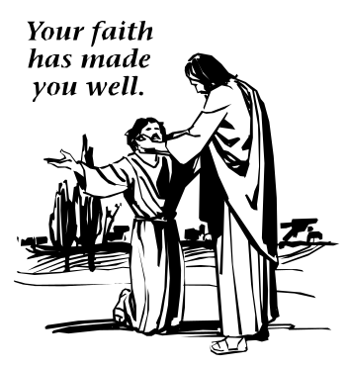
Discussion: (Share your thoughts after a moment of silence)

What do you “give thanks to God” for?
Closing Prayer:

Thanks be to You, Lord Jesus Christ,
-for all that you have given me.
Thanks be to You, Lord Jesus Christ,
-for all that you have taken away from me.
Thanks be to You, Lord Jesus Christ,
-for all that You have left me. Amen

TWENTY-NINTH SUNDAY IN ORDINARY TIME
October 20, 2019

Gospel: (Luke 18:1-8)
Jesus told his disciples a parable about the necessity for them to pray always without becoming weary. He said, “There was a judge in a certain town who neither feared God nor respected any human being. And a widow in that town used to come to him and say, ‘Render a just decision for me against my adversary.’ For a long time the judge was unwilling, but eventually he thought, ‘While it is true that I neither fear God nor respect any human being, because this widow keeps bothering me I shall deliver a just decision for her lest she finally come and strike me.” The Lord said, “Pay attention to what the dishonest judge says. Will not God then secure the rights of his chosen ones who call out to him day and night? Will he be slow to answer them? I tell you, he will see to it that justice is done for them speedily. But when the Son of Man comes, will he find faith on the earth?

Reflection:
Both weariness and persistence are things we can all relate and connect to with little difficulty. Sometimes when we are most weary it’s simply persistence in getting the task finished, ending the workday, or keeping a goal in mind that gets us through. Persistence. Tenacity. Stubbornness. Stick-to-itiveness. In this gospel it is the widow’s persistence that eventually wins her justice. Because God is just and concerned for the rights of the downtrodden, persistent prayer always leads to justice. But for many, setting aside any definite time for prayer during the day may seem all but impossible. Persistence in praying “always” might need to take the form in our lives of developing the habit of being aware of God’s abiding presence and blessings even in our busyness. The place and manner of prayer aren’t nearly so important as the fact that we pray—“always and without ceasing.” (Living Liturgy, p. 228)

Vincentian Meditation:
Sometimes I imagine that the reason of God’s delay in answering our prayers is that He wants to make us ready to accept what He desires to give us. Often we ask God for favors with our heads but not with our hearts. At other times we ask God for favors with our hearts but not our heads. He desires us to ask with both our hearts and our heads. Prayer must always be an expression of the love that is in us for God, for His world, for His Church and for those who have so much less that we have, namely, His poor. (McCullen, Deep Down Things, p.143)
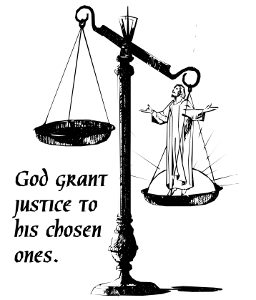
Discussion: (Share your thoughts after a moment of silence)

How have you prayed with “your heart and your head?”

Closing Prayer:

For the grace to bring God’s blessing on those who are suffering,
-Lord, help us to pray with our heart and our head.
For the grace to bring God’s justice to the rights of the downtrodden,
-Lord, help us to pray with persistence and faith.
Amen

THIRTIETH SUNDAY IN ORDINARY TIME
October 27, 2019

Gospel: (Luke 18:9-14)
Jesus addressed this parable to those who were convinced of their own righteousness and despised everyone else. “Two people went up to the temple area to pray; one was a Pharisee and the other was a tax collector. The Pharisee took up his position and spoke this prayer to himself, ‘O God, I thank you that I am not like the rest of humanity—greedy, dishonest, adulterous—or even like this tax collector. I fast twice a week, and I pay tithes on my whole income.’ But the tax collector stood off at a distance and would not even raise his eyes to heaven but beat his breast and prayed, ‘O God, be merciful to me a sinner.’ I tell you, the latter went home justified, not the former; for whoever exalts himself will be humbled, and the one who humbles himself will be exalted.”

Reflection:
The Pharisee was righteous and his boast before God was true: he does exemplary things (fasting and paying tithes), even more than is expected. His prayer, however, while addressed to God in thankfulness, is actually filled with himself and his own pride. He “took up his position,” presumably one where he will be seen and recognized. He praises himself rather than God. He does not acknowledge who God is but, rather, he simply exalts himself. Tax collectors, on the other hand, were hated and known for their unscrupulous practices. But the tax collector’s prayer allows God to be God and to show mercy. The tax collector stands afar off, but his prayer draws him near to God. Justification is addressing God as God and letting God be God. It is acknowledging humbly who we are before God: sinners in need of mercy. Good works alone don’t justify us—but only humility in the face of our all-holy and merciful God brings exaltation. (Living Liturgy, p.232)

Vincentian Meditation:
It was precisely because the Pharisee despised others that he was not accepted by God, nor his prayer either. It is easy to despise others almost without knowing it. The next time we read this parable, we would do well at the end of it to stand for a moment at the door of the Temple and ask if we despise anybody. It is only when we have answered this question with a no that we can enter the temple and begin the prayer of the publican: “God be merciful to me, a sinner.” (McCullen, Deep Down Things, p. 585)

Discussion: (Share your thoughts after a moment of silence)

In our service to those who are poor is there anybody we “despise” or judge?
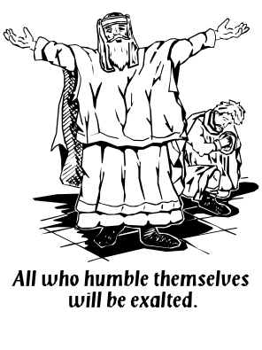
Closing Prayer:
For the grace to love those who are despised and rejected,
-Lord, hear our prayer.
For the grace to serve those who need our compassion and mercy,
-Lord, hear our prayer.
For the grace of humility and honesty,
-Lord, hear our prayer. Amen

FEAST OF ALL SAINTS
November 1

Gospel: (Matthew 5:1-12)
Jesus went up the mountain, and he began to teach them saying, “Blessed are the poor in spirit, for theirs is the kingdom of heaven. Blessed are they who mourn, for they will be comforted. Blessed are the meek, for they will inherit the land. Blessed are they who hunger and thirst for righteousness, for they will be satisfied. Blessed are the merciful, for they will be shown mercy. Blessed are the clean of heart, for they will see God. Blessed are the peacemakers, for they will be called children of God.

Reflection:
This solemnity of All Saints is a reminder and promise that through our baptism we already share in the glory of the saints whom we honor. The saints stand out as models who have been faithful to their baptismal commitment and give us courage and strength that we, too, can be faithful. We know some of the saints who have been canonized by name. And there are also countless other saints, our deceased relatives and friends among them, whom we also know by name. This multitude of faithful followers of Christ beckon us to hear what Jesus teaches in the gospel: “Blessed are you…” (Living Liturgy, p.240)

Vincentian Meditation:
The Beatitudes are a new scale of values. We might say that the Beatitudes are an invasion of God’s madness into the world of what humanity considers to be good sense. Have you ever tried to make a list of what you would consider your eight beatitudes? This could be very revealing and might show a very deep chasm between the values of our Lord and those by which we daily live. Do you feel comfortable with our Lord’s Beatitudes? Or has it been your experience, as it has been mine, that when you start to think or talk about one beatitude, you prefer to drop it because of its difficulty, and move on to another which you would consider more simple and easy? The beatitude that makes you feel most uncomfortable is probably the one that is most relevant to you personally. (McCullen, Deep Down Things, p.739)

Discussion: (Share your thoughts after a moment of silence)

Who is your favorite “Saint” canonized formally or informally?

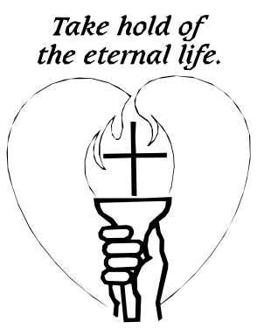
Closing Prayer:

May we work together to build up the kingdom of God, -Saints of God, intercede for us.
May our desire for God draw us more deeply into prayer,
-Saints of God, intercede for us.
May we comfort the broken hearted in their sorrow,
-Saints of God, intercede for us.
May we feed the hungry and bring mercy to the poor,
-Saints of God, intercede for us.
May we be peacemakers,
-Saints of God, intercede for us. Amen

COMMEMORATION OF ALL THE FAITHFUL DEPARTED
November 2

Gospel: (John 17:24-26)
Jesus raised his eyes to heaven and said: “Father, those whom you gave me are your gift to me. I wish that where I am they also may be with me, that they may see my glory that you gave me, because you loved me before the foundation of the world. Righteous Father, the world also does not know you, but I know you, and they know that you sent me. I made known to them your name and I will make it known, that the love with which you loved me may be in them and I in them.”

Reflection:

Remembering our departed loved ones in our prayers on this feast day of “All Souls” is a way of keeping them close to us. Also, praying for the dead, and to the dead, is an important part of the grieving process. Just as we grew in our relationships with out loved ones during their lifetime, so do we continue to deepen our love for them as we remember them in prayer after their death. Praying for the dead reminds us that death isn’t an end but a beginning of new life. Our prayers can be a concrete expression of our belief in everlasting life. (Living Liturgy, p.242)

Vincentian Meditation:

In reflecting on death, St. Vincent wrote: “All our life is but a moment which flies away and disappears quickly. Alas, the seventy years of my life which I have passed, seem to me but a dream and a moment. Nothing remains of them but regret for having so badly employed this time. Let us think of the dissatisfaction we will have at our death, if we do not use this time to be merciful. Let us then be merciful and let us exercise mercy towards all in a way that we will never find a poor man without consoling him….O Saviour, do not permit that we abuse our vocation. Do not take away from us the spirit of mercy, because what would become of us if You should withdraw your mercy from us. Give us, then, that mercy along with the spirit of gentleness and humility.” (McCullen, Deep Down Things, p.137)

Discussion: (Share your thoughts after a moment of silence)

Who do you remember and pray for especially this “All Souls Day”?

Closing Prayer:
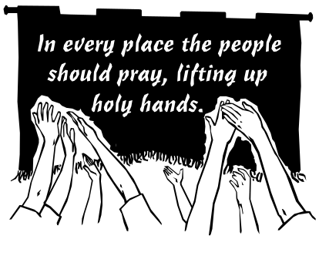
Let us remember our friends and family who have gone before us,
-may they celebrate now in the feast of heaven.
Let us remember those who suffered death in violence and war,
-may they be gently received at the table of love.
Let us remember all the poor who have gone before us,
-may they receive the wine of peace and the bread of life.
Let us remember the members of our Conference who have died,
-may they rest in the mercy of God. Amen

THIRTY-FIRST SUNDAY IN ORDINARY TIME
November 3, 2019

Gospel: (Luke 19:1-10)
A man named Zacchaeus, who was a chief tax collector and also a wealthy man, was seeking to see Jesus, but he could not see him because of the crowd, for he was short in stature. So he ran ahead and climbed a sycamore tree in order to see Jesus, who was about to pass that way. When he reached the place, Jesus looked up and said, “Zacchaeus, come down quickly for today I must stay at your house.” And he came down quickly and received him with joy. When they all saw this, they began to grumble, saying “He has gone to stay at the house of a sinner.” But Zacchaeus said to the Lord, “Behold, half of my possessions, I shall give to the poor, and if I have extorted anything from anyone I shall repay it four times over.” And Jesus said to him, “Today salvation has come to this house because this man too is a descendant of Abraham. For the Son of Man has come to seek and to save what was lost.”

Reflection:
In this gospel we see an aspect of prayer that is creative in diligently seeking out God. Most of us don’t have to be so creative or go to the extreme of climbing a tree to encounter Jesus. However, this gospel forewarns us that we ought not be complacent in our spiritual lives. We go to Mass every Sunday and encounter Jesus; we might think this is sufficient. Zacchaeus reminds us that we must also be willing to change and grow, and to be vigilant about our relationships with others. Creativity in seeking Jesus might mean that we are innovative in our personal prayer life rather than continually reciting the prayers we might have learned long ago. Zacchaeus encourages us to ask: What prayers might better meet our spiritual needs now? (Living Liturgy, p.236)

Vincentian Meditation:
This passage of St. Luke’s gospel is a study in the attitude of acceptance and non- acceptance. Zacchaeus accepts our Lord joyfully and the sign of his acceptance is his open house and his resolution to give half of his goods to the poor. Outside the house we have non-acceptance, the crowd protesting and murmuring because Jesus had accepted Zacchaeus with all his defects, physical and spiritual. There may be particular people whom we do not accept, or to whom we manifest an attitude of coldness and reserve. In this we are not like Christ. So often in our contacts with others we set up in our minds conditions for accepting people or rejecting them. May Christ lower the barriers of prejudice in our minds and open our hearts, not only to the poor, but to those whom we would exclude through personal dislike. (McCullen, Deep Down Things, p. 647-48)
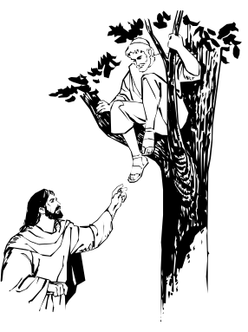
Discussion: (Share your thoughts after a moment of silence)

In what ways are we accepting or non-accepting of others?

Closing Prayer:

For the grace to be creative in seeking Jesus,
-Lord, hear our prayer.
For the grace to let go of our prejudices,
-Lord, hear our prayer. Amen

THIRTY-SECOND SUNDAY IN ORDINARY TIME
November 10, 2019

Gospel: (Luke 20:27-38)

Jesus said: “The children of this age marry and remarry; but those who are deemed worthy to attain the coming age and to the resurrection of the dead neither marry nor are given in marriage. They can no longer die, for they are like angels; and they are the children of God because they are the ones who will rise. That the dead will rise even Moses made known in the passage about the bush, when he called out ‘Lord,’ the God of Abraham, the God of Isaac, and the God of Jacob; and he is not God of the dead, but of the living, for to him all are alive.”

Reflection:

The gospel isn’t really about marriage, but about resurrection and the new life it brings. Resurrection is a way of living with surety and hope. Resurrection is surety about eternal life because we have remained faithful to God. The basis for our belief in resurrection is hope. Although hope always has a future orientation about it, when we have confidence in God’s grace to bring about change in us, when we have patience with ourselves while that change comes about, we already have something of the future in the present—we are already living this new, resurrected life when we remain faithful to God. The relationship to be celebrated in resurrected life is the relationship of being “children of God” in an everlasting relationship with the living God. We must have zeal for God and God’s ways such that it is a way of life for us. God is a God of the living. That is the core of our hope. (Living Liturgy, p.244)

Vincentian Meditation:

The Old Testament prophets have been described as men who had not optimism, but who had hope. The distinction is a valid one. Optimism is a human quality; hope is a spiritual one. A Christian may not always be optimistic about the world, but he need never be without hope, for Jesus Christ has risen and is with us. Therefore, at no time should we be without hope for the future. (McCullen, Deep Down Things, p.29)

Discussion: (Share your thoughts after a moment of silence)

What are the signs of hope that you see in today’s world?
10
Closing Prayer:

Jesus, our hope,
-guide us in our decisions.
Jesus, our hope,
-guard us in our choices.
Jesus, our hope,
-root us in your words. Amen

THIRTY-THIRD SUNDAY IN ORDINARY TIME
November 17, 2019

Gospel: (Luke 21:5-19)

Jesus said: “When you hear of wars and insurrections, do not be terrified; for such things must happen first, but it will not immediately be the end. Nations will rise against nation, and kingdom against kingdom. There will be powerful earthquakes, famines, and plagues from place to place; and awesome sights and mighty signs will come from the sky. Before all this happens, however, they will seize and persecute you, they will hand you over to the synagogues and to prisons, and they will have you led before kings and governors because of my name. It will lead to your giving testimony….You will be hated by all because of my name, but not a hair on your head will be destroyed. By your perseverance you will secure your lives.

Reflection:

The gospel predicts end times; our challenge though is to live faithfully now. Jesus lists signs of the end times such as wars, insurrection, earthquakes, famine, plagues, but we need not fear these cosmic events as frightening and disheartening as they may be. Jesus admonishes that these signs are now and so the future is “now.” The condition for our life and our not having fear of the end times is to trust in God and to live by Jesus’ name now. As disciples we must never lose the perseverance to face these tribulations and bring about a better world in which all might live in peace. We must live faithfully now. Everyday is an opportunity to live discipleship fully and confidently. When all is said and done, unity with Jesus now is the only thing that guarantees unity with Jesus for all eternity. (Living Liturgy, p.248)

Vincentian Meditation:

We are pilgrims on the way to heaven. Jesus is our way. We are following the right way if Jesus Christ can at all times share our thoughts, our words, our actions. St. Vincent often proposed to people as a program for their lives the simple question: “What would Jesus Christ do, if He were in my place now?” (McCullen, Deep Down Things, p. 736)

Discussion: (Share your thoughts after a moment of silence)

What would Jesus Christ do, if He were in our Conference now?
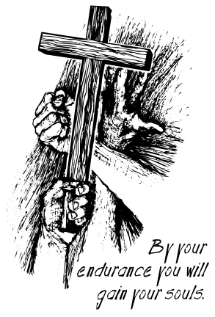
Closing Prayer:

May we fearlessly speak your love to all we meet,
-Jesus, teach us to love one another.
May we accompany the poor in their search for God,
-Jesus, teach us to love one another.
May we pray for the peace that cannot be achieved through
acts of violence and war,
-Jesus, teach us to love one another. Amen

THE SOLEMNITY OF OUR LORD JESUS CHRIST THE KING
November 24, 2019

Gospel: (Luke 23: 35-43)

The rulers sneered at Jesus and said, “He saved others, let him save himself if he is the chosen one, the Christ of God.” Even the soldiers jeered at him. As they approached to offer him wine they called out, “If you are the King of the Jews, save yourself.” Above him there was an inscription that read, “This is the king of the Jews.” Now one of the criminals hanging there reviled Jesus, saying, “Are you not the Christ? Save yourself and us. The other, however, rebuking him said in reply, “…we have been condemned justly, for the sentence we received corresponds to our crimes, but this man has done nothing criminal.” Then he said, “Jesus, remember me when you come into your kingdom.” Jesus replied to him, “Amen, I say to you, today you will be with me in Paradise.”

Reflection:

On this last Sunday of the liturgical year we celebrate Christ’s kingship. The notion of “king” can conjure up images of power, wealth and self-serving rule. But here we have a King who has no power and wealth; his throne is a cross and his rule is suffering and death. Would we be like the thief crucified with Jesus who wishes Jesus to abuse his power to save himself and them? Or would we be like the thief who recognizes his own sinfulness and Jesus’ goodness? Jesus demonstrates his kingship not by saving himself but by saving others. The reign of God is not in power but in mercy. The cross is where we least expect a king to be. Yet this is how God’s kingdom is established and where our discipleship begins. Jesus demonstrates his kingship not by power but by loving reassurance that Paradise awaits faithful disciples. (Living Liturgy, p. 252)

Vincentian Meditation:

Devotion to Christ the King means loving those people whom, when he was a king on earth, Jesus liked to have close about him—the poor. Devotion to Christ the King means loving and being servants of the poor in the way and in the spirit with which Jesus served them when he was on earth. Devotion to Christ the King means opposing and rejecting violence in all its forms. Devotion to Christ the King means working for peace and reconciliation in our society, for his kingdom is one of love and justice and peace. (McCullen, Deep Down Things, p.569)
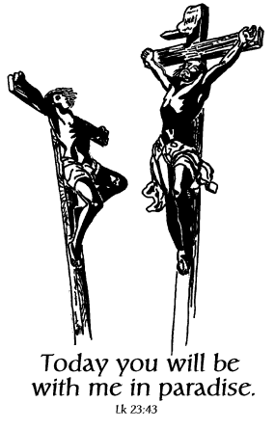
Discussion: (Share thoughts on the readings after a moment of silence)
How are we showing our devotion to Christ the King?

Closing Prayer:

Christ our King, source of compassion,
- may we bring peace to all who have lost hope.
Christ our King, source of reconciliation,
-may we reject violence in all its forms .
Christ our King, source of peace,
-may we have the courage to work for justice. Amen

FEAST OF OUR LADY OF THE MIRACULOUS MEDAL
November 27

Gospel: (Luke 1:26-38)

The angel Gabriel was sent from God to a town of Galilee named Nazareth, to a virgin named Mary. The angel said to her: “Hail full of grace! The Lord is with you…. Do not be afraid, Mary, for you have found favor with God. Behold, you will conceive in your womb and bear a son, and you shall name him Jesus… The Holy Spirit will come upon you and the power of the Most High will overshadow you. Therefore, the child to be born will be called holy, the Son of God.” Mary said: “ I am the handmaid of the Lord. May it be done to me according to your word.”

Reflection:

On November 27, 1830 Mary appeared to St. Catherine Laboure in the motherhouse of the Daughters of Charity, in Paris. The Blessed Mother was standing on a globe with streams of light coming from her hands. Around her were the words “O Mary, conceived without sin, pray for us who have recourse to thee.” Sister Catherine was told that a medal was to be made of this picture. Soon, because of all the wonderful graces obtained by those who wore the medal, it was called the “Miraculous Medal.” The Vincentian Family has always been rooted in a special devotion to Mary, and the Miraculous Medal is one of our treasured gifts.

Vincentian Meditation:

“I do not know how to find words for what I experienced and perceived, or for the beauty and the splendor of those magnificent rays (coming from the hands of the Blessed Virgin). Mary told me, “They are the symbol of the graces which I shed on those who ask me for them. Have a medal struck according to this model; all those who wear it, especially if they wear it around the neck, will receive great graces, and these graces will be abundant for those who wear it with confidence.” (From St. Catherine Laboure’s account of the apparitions, November 27,1830)

Discussion: (Share thoughts on the readings after a moment of silence)

How do you share in the Vincentian devotion to Mary?
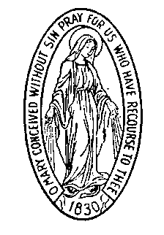
Closing Prayer:

Our Lady of the Miraculous Medal intercede for us as we come
to the foot of the altar with the cries of the world,
-Pray for us who have recourse to you.
In solidarity with those who cannot voice their own cries for
healing, compassion, and strength, we say,
-Pray for us who have recourse to you.
Accompanying the oppressed peoples of the world, we say,
-Pray for us who have recourse to you. Amen

FEAST OF SAINT CATHERINE LABOURE
November 28

Gospel: (Luke 12:32-34)

Jesus said to his disciples: “ Do not live in fear, little flock. It has pleased your Father to give you the kingdom. Sell what you have and give alms. Get purses for yourselves that do not wear out, never-failing treasure with the Lord which no thief comes near nor any moth destroys. Wherever your treasure lies, there your heart will be.”

Reflection:

St. Catherine Laboure entered the Daughters of Charity in 1830. When she was a novice, the Blessed Mother appeared to her several times in the Motherhouse Chapel asking that a medal be made in her honor. Although the Miraculous Medal became well known through out the world, Sister Catherine devoted her life to the service of the poor elderly in silence and humility for forty-six years. She is known as the saint of silence, as she kept her secret of being the one who saw Mary until her death. She was a woman of profound prayer and service, a true “mystic in action” as a Daughter of St. Vincent de Paul and St. Louise de Marillac. She is, in a special way, the patroness of the elderly.

Vincentian Meditation:

“Whenever I go to the chapel, I put myself in the presence of our good Lord, and I say to him, ‘Lord I am here. Tell me what you would have me to do.’ If he gives me some task, I am content and I thank him. If he gives me nothing, I still thank him since I do not deserve to receive anything more than that. And then, I tell God everything that is in my heart. I tell him about my pains and joys, and then I listen… If you listen, God will also speak to you, for with the good Lord, you have to both speak and listen. God always speaks to you when you approach him plainly and simply.” (Words of St. Catherine Laboure)

Discussion: (Share thoughts on the readings after a moment of silence)
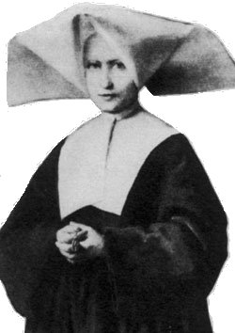
In your prayer do you “speak and listen?” How has God directed
you in your service to the poor- giving you a “task to do”?

Closing Prayer:

St. Catherine, servant of the sick and elderly poor,
-help us to grow in the virtue of humility.
St. Catherine, visionary of the Miraculous Medal,
-increase our devotion to the Blessed Virgin Mary
St. Catherine, model of prayer and service,
-show us how to be contemplatives in action.
St. Catherine, woman of prayer
-give us the grace to approach God plainly and simply. Amen

FIRST SUNDAY OF ADVENT
December 1, 2019
Gospel: (Matthew 24:37-44)

Jesus said to his disciples: “As it was in the days of Noah, so it will be at the coming of the Son of Man. In those days before the flood, they were eating and drinking, marrying and giving in marriage, up to the day that Noah entered the ark. They did not know until the flood came and carried them all away. So will it be also at the coming of the Son of Man. Two men will be out in the field; one will be taken, and one will be left. Two women will be grinding at the mill; one will be taken, and one will be left. Therefore, stay awake! For you do not know on which day your Lord will come. Be sure of this: if the master of the house had known the hour of the night when the thief was coming, he would have stayed awake and not let his house be broken into. So too, you also must be prepared, for at an hour you do not expect, the Son of Man will come.”

Reflection:

Always at the beginning of Advent the Church invites us to think ahead. The gospel contains a clear warning and a judgment, admonishing us to “stay awake.” Instead of leading us to hopelessness and paralyzing fear, the gospel surprises us with an opportunity to be prepared. Instead of floundering, we have our whole lifetime and the guidance of the priceless gift of the Good News of Jesus Christ to accompany us on our journey into the future. This is what God offer us so we will not be left.
(Living Liturgy, p. 2)

Vincentian Meditation:

There is an Advent spirit in the heart of every human person. It is one of longing, of yearning for a fulfillment that somehow lies beyond ourselves. It flows from our deeply rooted human incompleteness. Augustine uttered the classic description of this spirit: “You made us for yourself, O Lord, and our hearts are restless until they rest in you.” All of us long for something more, as we make our pilgrim way. Even when human sinfulness pulls people to focus on power, pleasure, fame, or financial prosperity, they often find themselves moving aimlessly, without fulfillment. “Our hearts are restless until they rest in you.”Advent celebrates human yearning. We long for the coming of the Lord. (Maloney, Seasons in Spirituality, p.45)

Discussion: (Share thoughts on the readings after a moment of silence)
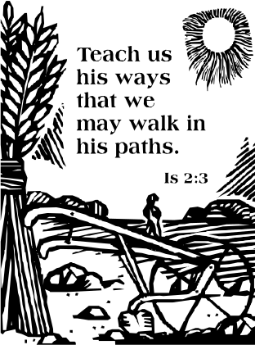
This Advent what are you yearning or longing for?

Closing Prayer:

Lord, as we await the fulfillment of your promise,
-give us a heart that yearns for you.
Lord,You came as a visible sign of love,
-give us a heart that believes in you.
Lord, strengthen us by your grace,
-give us a heart that “stays awake and prepared.” Amen

SECOND SUNDAY OF ADVENT
December 8, 2019

Gospel: (Matthew 3:1-12)
John the Baptist appeared, preaching in the desert of Judea and saying, “Repent, for the kingdom of heaven is at hand!” It was of him that the prophet Isaiah had spoken when he said: “A voice of one crying in the desert, Prepare the way of the Lord, make straight his paths”….At that time Jerusalem, all Judea, and the whole region around the Jordan were going out to him and were being baptized by him in the Jordan as they acknowledge their sins…. John announced, “I am baptizing you with water, for repentance, but the one who is coming after me is mightier than I. I am not worthy to carry his sandals. He will baptize you with the Holy Spirit and fire. His winnowing fan is in his hand. He will clear his threshing floor and gather his wheat into his barn, but the chaff he will burn with unquenchable fire.”

Reflection:
John the Baptist is prophet, judge, precursor. With these three roles we note a parallel with the prophetic, kingly, and priestly roles in Israel that come to fulfillment in Jesus Christ. John is the bridge between Israel of old and Jesus the Messiah. John forcefully reminds us that vindication or punishment is our choice, according to the life we lead. Who is this strange man John? He is the voice that cries out to us an Advent message: “Repent, for the kingdom of heaven is at hand!” For those of us who are totally taken up with the present moment—simply getting up, getting to work, keeping the house and preparing meals, etc.—it may seem strange to live in light of a future event. The beginning of Advent is a time when the Church reminds us that how we do these everyday things is how we bear fruit and receive everlasting life. (Living Liturgy, p. 10)

Vincentian Meditation:
John knew the Advent secret: He focused his whole life on the coming of Jesus. “I am not the Christ. Another comes after me. He will baptize you with the Holy Spirit and with fire.” He realized that his all-consuming vocation was to prepare the way of the Lord. Our vocation is very similar. St. Vincent tells us that the person of Jesus must be absolutely central in our lives, as it was for John the Baptist. As Vincentians we dedicate our whole lives to following Christ. We seek to share in his love and reverence for the Father and his compassionate and effective love for the poor. With him we trust in God’s Providence, which rules over all. For Vincentians, as for John the Baptist, there is nothing else but Jesus. (Maloney, Seasons in Spirituality, p.47)
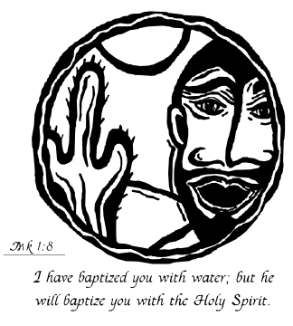
Discussion: (Share thoughts on the readings after a moment of silence)

How does Advent call you to “prepare the way of the Lord?”

Closing Prayer:
Come Lord Jesus, give us the grace to,
-keep Jesus absolutely central in our lives.
Come Lord Jesus, give us the grace to,
-prepare the way of the Lord.
Come Lord Jesus, give us the grace to,
-bring love and compassion to the poor and the forgotten. Amen

FEAST OF THE IMMACULATE CONCEPTION
December 9, 2019 (Transferred)

Gospel: (Luke 1:26-38)
The angel Gabriel was sent from God to a town of Galilee called Nazareth, to a virgin betrothed to a man named Joseph, of the house of David, and the virgin’s name was Mary. And he said to her, “Hail, full of grace! The Lord is with you…Do not be afraid, Mary for you have found favor with God. Behold, you will conceive in your womb and bear a son, and you shall name him Jesus…The Holy Spirit will come upon you, and the power of the most high will overshadow you. Therefore, the child to be born will be called holy, the Son of God. And behold, Elizabeth, your relative, has also conceived a son in her old age…for nothing is impossible for God.” Mary said, “Behold, I am the handmaid of the Lord. May it be done to me according to your word.”

Reflection:
The dogma of Mary’s being conceived without sin—what we refer to as the Immaculate Conception—was defined by Pope Pius IX in 1854.Mary is the model of holiness who calls us to be who we were meant to be: innocent before God. Mary’s innocence and holiness were God’s special favor to her. This solemnity reminds us that God’s desire for each of us is to have the same innocence and holiness. Just as Mary and her divine Son said “yes” to God’s will for them, so are we called through our baptismal commitment to do the same. But that doesn’t mean that their example of holiness and fidelity is beyond us. Their lives were ordinary—wife and mother, son of a carpenter—but they lived the ordinary according to God’s word. Our ordinary days—being wife or husband, mother or father, brother or sister, neighbor or friend, employer or employee—are to be lived as a “yes” to God. This is how we are holy too. (Living Liturgy, p.6)

Vincentian Meditation:
Frederic Ozanam had a strong devotion to the Blessed Virgin Mary, from his youth to his death. Frederic was insistent that the Society take Our Lady of the Immaculate Conception as its patroness. The first members of the Society chose December 8th as their special Marian feast twenty years before the formal proclamation of the dogma in 1854 by Pope Blessed Pius IX and a year after Frederic’s death! Vincentians implore Our Lady of the Immaculate Conception, their patroness, to intercede for their Councils and Conferences, their lives and ministry. (SVDP Manual, p.34-35)

Discussion: (Share thoughts on the readings after a moment of silence)

How does our Conference show devotion to Mary?

Closing Prayer:

Through Mary, conceived without sin,
-we ask for the grace of holiness.
Through Mary, and her Immaculate Conception,
-we ask for healing for those who are brokenhearted.
Through Mary, patroness of our Society.
-we ask for the grace of fidelity for all Vincentians. Amen

THIRD SUNDAY OF ADVENT
December 15, 2019

Gospel: (Matthew 11:2-11)
When John the Baptist heard in prison of the works of the Christ, he sent his disciples to Jesus with this question, “Are you the one who is to come, or should we look for another?” Jesus said to them in reply, “Go and tell John what you hear and see: the blind regain their sight, the lame walk, lepers are cleansed, the deaf hear, the dead are raised, and the poor have the good news proclaimed to them. And blessed is the one who takes no offense at me.” As they were going off, Jesus began to speak to the crowds about John, “What did you go out to the desert to see? A reed swayed by the wind? Then what did you go out to see? Someone dressed in fine clothing? Those who wear fine clothing are in royal palaces. Then what did you go out to see? To see a prophet? Yes, I tell you, and more than a prophet. This is the one about whom it is written: Behold, I am sending my messenger ahead of you; he will prepare your way before you.

Reflection:
Jesus, in answering John’s question gives a most startling answer. He recounts an alternative world vision that is actually taking place because of his ministry: “the blind regain their sight, the lame walk, lepers are cleansed, the deaf hear, the dead are raised, and the poor have the good news proclaimed to them.” In other words, he is saying “Don’t take my word for it that I am who you are looking for. Look at what I’ve accomplished! The good news can be seen and touched and felt and heard in the lives of people.” This is why doubts can be appeased and all can know that Jesus is, indeed, “the one who is to come.”We are now charged to take up Jesus’ ministry. We can’t ask people to take our word for it; our actions speak for us—or our non-actions. Either we take up Jesus’s ministry or we don’t. (Living Liturgy, p. 14)

Vincentian Meditation:
John the Baptist makes it very clear that we will live genuinely for Christ only if we are willing to die for him. Only the person who is practiced in the art of daily dying will be able to hand themselves over to God in an act of final resignation, as John the Baptist did. Daily dying consists in pouring out one’s energies in the service of the poor, in listening attentively, in praying faithfully, in living harmoniously with others, in seeking reconciliation, in doing penance, in renouncing anything that is an obstacle to following Christ. John the Baptist calls us to prepare the way of the Lord by eliminating from our lives whatever impedes his coming. (Maloney, Seasons in Spirituality, p.48)

Discussion: (Share thoughts on the readings after a moment of silence)
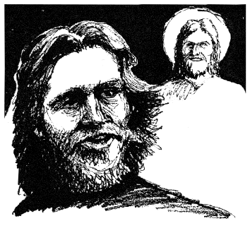
How do our actions show that we are doing Jesus’ ministry?”

Closing Prayer:

As our Advent journey continues, we turn in hope to Christ and pray:
-Come, Lord Jesus, and do not delay?
Strengthen all Vincentians in their efforts to reveal your love, -Come, Lord Jesus, and do not delay. Amen

FOURTH SUNDAY OF ADVENT
December 22, 2019

Gospel: (Matthew 1:18-24)
This is how the birth of Jesus Christ came about. When his mother Mary was betrothed to Joseph, but before they lived together, she was found with child through the Holy Spirit. Joseph, her husband, since he was a righteous man, yet unwilling to expose her to shame, decided to divorce her quietly. Such was his intention when, behold, the angel of the Lord appeared to him in a dream and said, “Joseph, son of David, do not be afraid to take Mary your wife into your home. For it is through the Holy Spirit that this child has been conceived in her. She will bear a son and you are to name him Jesus, because he will save his people from their sins.” All this took place to fulfill what the Lord said through the prophet: Behold, the virgin shall conceive and bear a son, and they shall name him Emmanuel, which means “God is with us.” When Joseph awoke, he did as the angel of the Lord had commanded him and took his wife into his home.

Reflection:
The gospel for this Fourth Sunday of Advent helps us to reflect on the relationship between Jesus’ conception by the Holy Spirit and his birth, as both are clothed in the mystery of God’s revelation and presence to us. Two names are given the One incarnated in Mary’s womb: Jesus, meaning “God saves the people from their sins” and Emmanuel, meaning “God is with us.” The names reveal that the presence of God among us is experienced most profoundly in the forgiveness of our sins. This is the deepest mystery that we celebrate as we see how the joy of Christmas connects and points to the triumph of Easter. Not even the compassionate, righteous Joseph could imagine such a merciful work of God. It is to dream the impossible: God with us (Emmanuel) not as a condemnation but as Savior(Jesus). (Living Liturgy, p.18)

Vincentian Meditation:
The mystery of the birth of Jesus is supremely a mystery of love. The purpose of the coming of Christ was to speak to us humans about the love which the great, eternal and all-powerful God has for us short-lived, weak, fragile and sinful human beings. A newborn infant calls forth from our hearts love. The language of God at Christmas is one of love. Our vocation as Vincentians is to continue learning the language of love, not only at Christmas but throughout our lives. It is the language that we must learn to speak if we wish to draw near to the poor. (McCullen, Deep Down Things, p.509)

Discussion: (Share thoughts on the readings after a moment of silence)

How have we learned the language of love this Advent?


Closing Prayer:
As we prepare for Christmas we pray for the poor and lonely,
-may our lives be a sign of faith.
We pray for those who do not know that God is our “Savior”,
-may our lives be a sign of hope.
We pray for those who do not know that God is “Emmanuel”,
-may our lives be a sign of charity. Amen

CHRISTMAS
December 25

Gospel: (Luke 2:15-20)
When the angels went away from them to heaven, the shepherds said to one another, “Let us go, then, to Bethlehem to see this thing that has taken place, which the Lord has made known to us.” So they went in haste and found Mary and Joseph, and the infant lying in the manger. When they saw this, they made known the message that had been told them about this child. All who heard it were amazed by what had been told them by the shepherds. And Mary kept all these things, reflecting on them in her heart. Then the shepherds returned, glorifying and praising God for all they had heard and seen, just as it had been told to them.

Reflection:
The angels told the shepherds that the Messiah was born and where to find him. How and when are we told? God reveals divine presence in the smile of another, in someone’s generous offer, in a plea for help, in the cry of the poor and oppressed, in the child needing reassurance, in the aged needing a listening heart, in the sick needing a consoling hand. This is how we make “known the message”: to reach out to another with God’s compassion, mercy, forgiveness, healing love. The mystery of Christmas is that God is incarnate. Today we see not a Baby in a manger, but a saving God working through and among us. This is what we make known. (Living Liturgy, p.24)

Vincentian Meditation:
The only gift we can offer our newborn Saviour is our hearts within which lie our wills. Aligning our wills ever more closely with his will, at all times and in all circumstances, is the only gift we can offer our Savior on Christmas day and every other day throughout the year. In the words of Cardinal Newman: “May each Christmas as it comes find us more and more like him who at this time became a little child for our sake, more humble, more holy, more happy and more full of God. (McCullen, Deep Down Things, p.675)

Discussion: (Share thoughts on the readings after a moment of silence)

How have we “made known the message” of God’s love this Christmas?

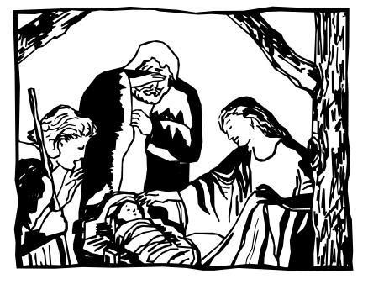
Closing Prayer:

On this day, joy was reborn into the world,
-may we share the joy of Christ with everyone.
On this day, hope was reborn into the world,
-may we bring the hope of Christ to those most in need.
On this day, love was reborn into the world,
-may we bring the love of Christ to others in compassion,
On this day, peace was reborn into the world,
-may we bring the peace of Christ to our family and our
world. Amen

THE HOLY FAMILY OF JESUS, MARY AND JOSEPH
December 29, 2019

Gospel: (Matthew 2:13-15. 19-23)

When the magi had departed, behold, the angel of the Lord appeared to Joseph in a dream and said, “Rise, take the child and his mother, flee into Egypt, and stay there until I tell you. Herod is going to search for the child to destroy him.” Joseph rose and took the child and his mother by night and departed for Egypt. He stayed there until the death of Herod, that what the Lord had said through the prophet might be fulfilled: Out of Egypt I called my son.

Reflection:

As parents, Joseph and Mary, were not preserved from hardships. These simple parents surely had apprehensions as they traveled to Egypt. Yet they responded faithfully and obediently to God’s messages. They trusted God’s ways. We too all face challenges in responding to God faithfully and obediently. The holiness of a family is not dependent upon perfection or an easy road. Whether we are a traditional family or a single parent family, whether we have biological or adopted or foster children or no children, whether we live in an expensive home or a subsidized rental unit makes no difference for living as a holy family. What does make a difference is hearing God’s messages and doing God’s will. Trust in God’s ways. You, too, are a holy family. (Living Liturgy, p.28)

Vincentian Meditation:

In his faithful response to God’s commands, Joseph also knew how to “listen to the word of God and act on it.” Joseph stands with eager expectation at the threshold of transcendence. From the darkness of his own limited understanding, he is continually peering into the mystery of God. Surely he cannot fathom the mystery of God’s plan, but with loving compassion he bows in reverence to God’s incomprehensible ways. There is something very beautiful about Joseph’s contacts with the transcendent mystery of God. He was not a monk. He was a carpenter, and he raised his son in the same trade. Yet in the midst of his daily manual labor and family life, Joseph was surrounded by the mystery of God and he penetrated it with faith. He trusted in God’s daily providence. When he read the signs of God’s will, he rushed to put them into practice. (Maloney, Seasons in Spirituality, p.52-53)

Discussion: (Share thoughts on the readings after a moment of silence)
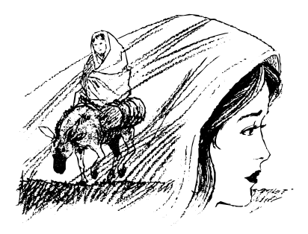
How have you found “God’s daily providence” in your family life?

Closing Prayer:

O God, You bless us with the gift of faith,
-continue to strengthen our trust in you.
O God, You bless us with the gift of family,
-keep them always in your love.
O God, You bless our Conference in countless ways,
-we ask for your continued grace and guidance. Amen

REFERENCES:

*Maloney, Robert CM. Seasons in Spirituality: Reflections on Vincentian Spirituality in Today’s World, New City Press, Hyde Park, New York, 1998.

*Father Robert Maloney was born and raised in Brooklyn, New York. He served
as the Superior General of the Congregation of the Mission and the
Daughters of Charity, and of the Vincentian Family from 1992-2004.

**McCullen, Richard CM. Deep Down Things, New City Press, Hyde Park, New York 1995.
** Father Richard McCullen was the Superior General of the Congregation of the
Mission and the Daughters of Charity, and of the Vincentian Family from 1980-
1992. Currently he lives in Dublin, Ireland.

Zimmerman, Joyce Ann C.PP.S. et al. Living Liturgy, The Liturgical Press, Collegeville, Minnesota, 2002.

Clip Art: Liguori Publications, Faithware –Cycle A, Liguori, Missouri, 1998.

For information contact:
Sister Kieran Kneaves, DC
Society of St. Vincent de Paul
Council of the United States
58 Progress Parkway
St. Louis, MO 63043-3706
Phone: 314-576-3993
E-MAIL: kkneaves@svdpusa.org

Copyright:

January 2004-The Society of St. Vincent de Paul Council of the United States.



The Vincentian Weekly Reflections have been developed
exclusively for use by the Society of St. Vincent de Paul
and the Vincentian Family. They cannot be reproduced
in any form without the expressed consent of the
National Council of the Society of St. Vincent de Paul.

