

**Article written by the 16th President General**

**Brother Renato Lima de Oliveira**

**Language: English**

***Let's have faith: God will protect and strengthen everyone***

***Vincentians during this battle against the coronavirus***

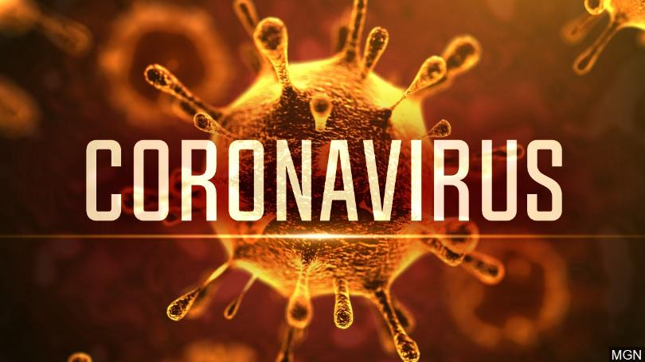In our spiritual journey as Christians, baptized and Vincentians, we have already experienced innumerable tribulations and challenges, in all areas of our lives: in the family, in the professional field, in studies, in the search for work, in the area of health, and among many other dimensions as human beings. Also in the Church and in the Society of Saint Vincent de Paul, we sometimes experience disappointments and setbacks that leave us letdown and very sad in certain situations.

In recent weeks, we have faced the **global coronavirus crisis**, a pandemic that is forcing social confinement and, of course, the prohibition of personal contact, especially with the elderly. Several important events, courses and assemblies are being postponed. Donations to our Conferences, Councils and Vincentian special works are being reduced. We all have to reinvent ourselves to keep Vincentian charity updated.

Anxiety about not being able to make home visits, as we used to, is psychologically impacting many brothers and sisters in all countries. The economy will be impacted. The poor will and the homeless be the most affected and the most vulnerable. However, as Vincentians, we will not be immune to this inevitability. We will also be affected and impoverished by these turn of events.

**Let us have faith!** Once, a more experienced Vincentian consoled me saying: *“There are lights and shadows everywhere, and in our Society, we face the same lights and the same shadows as in any other entity”.* This comment made me reflect on the necessary resignation when dealing with the difficulties of our life.

If we have faith in God and full trust in Our Lord Jesus Christ, we will overcome adversities. Shadows will immediately dissipate. We will beat the coronavirus! Everything will pass. Let's have faith! If you have financial difficulties, **have faith**, ask God to give you patience to obtain the financial resources you need. If you are unemployed, **have faith**, because God will show you several opportunities to start working again.

If you are sick, **have faith**, because Our Lady will not allow pain to invade your heart. If you have problems with your marriage or your relationships, **have faith**, because Our Lord wants your happiness and will help you. If you have children involved in the world of addictions or who walk in bad company, **have faith**, because Christ is the way, the truth and the full life, and he will not allow young people to get lost in the world.

If there are problems in the Church and in the SSVP, **have faith**, since these episodes are secondary compared to the immense benefits of the practice of charity, which is the purpose that led us to serve the poor. In my life as a Vincentian brother, I have experienced intense emotions and I have also seen moments that are not so favorable. But in all these episodes, **with much prayer and faith**, we managed to overcome all these challenges.

Therefore, in the face of this cruel reality, in times of war against the coronavirus, I tell you firmly: **be strong, be faithful and do not be discouraged**. *“The Lord himself goes before you and will be with you; he will never leave you nor forsake you. Do not be afraid; do not be discouraged”* (Deuteronomy 31, 8). Hold on to the Lord, because He will never forget us. There are many shadows that haunt us, but they will come out with the light of the Holy Spirit. When you least expect it, shadows will give way to light. *“And God said, ‘Let there be light’, and there was light. And God saw that the light was good. And God separated the light from the darkness”* (Genesis 1, 3s).

Let us continue to pray for all the SSVP members, for the great Vincentian Family and for the poor of the world. We will double our care with hygiene and public health. **We will no doubt win this battle!**