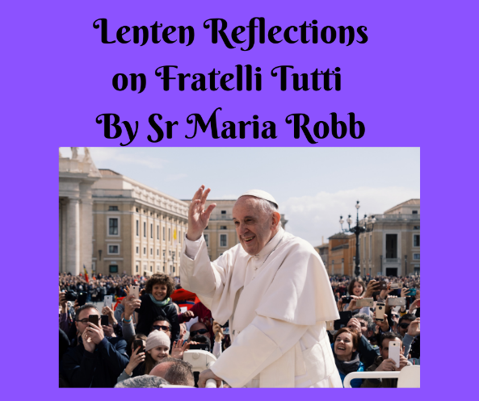
Fratelli Tutti
An Invitation to build a world based on fraternity and Social Friendship

Fratelli Tutti, Pope Francis’ Encyclical Letter on Fraternity and Social Friendship takes its title from the words St Francis used to address his sisters and brothers.
These words ‘Fratelli Tutti, speak to us of our belonging together as family, a totally inclusive family where no-one is an outsider regardless of race, culture, creed, social status etc.
Throughout the letter Pope Francis explores the realities and challenges we face if we are to truly live in fraternity and social friendship. He also indicates ways in which we can build a more just and peaceful world where everyone has their contribution to give, a world where war and globalised indifference has no place.
While Fratelli Tutti was being written the Covid 19 pandemic erupted and it soon became evident that as a world society we responded as individual countries offering fragmented solutions, unable to see this as a pandemic that affected the whole world. All our sisters and brothers were suffering from this pandemic; yet our vision was limited and in our ‘panic’ we had no insight into the need and value to respond globally to a global issue.
Pope Francis reminds us that, “no one can face life in isolation”, and the time has come now when we must “dream as a single human family”, in which “we are brothers and sisters all.” [Para 8]
St Vincent reminds us that, “Charity is the cement which binds Communities to God and persons to one another . . .” Let us allow the Charity of Christ to fill our hearts this Lent.
Reflection Points
Do I carry any prejudices that prevent me from truly acknowledging all people as my sisters and brothers in Christ?
Reflect on and thank God for the times you have experienced or witnessed fraternal support.

