Fratelli Tutti
An Invitation to build a world based on fraternity and Social Friendship
Reflection Lent Week 2
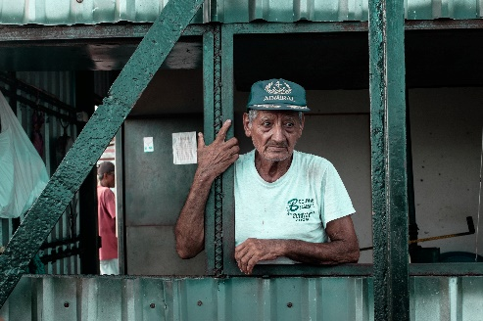

Written in the backdrop of the coronavirus pandemic, Pope Francis sets out in the first chapter of his letter, to describe some of the basic realities of our world today.
He describes it as a ‘throwaway world, where some parts of the human family can be readily sacrificed for the sake of others…’
Not only food and dispensable objects are thrown away and discarded, but ‘often human beings.’
This may seem a bit drastic, but Pope Francis cites the recent issues with the elderly as a result of the coronavirus as an example. The whole sad reality of migration, fleeing for safety, for economic purposes, trafficked people, the number of people turning to foodbanks in order to feed themselves and their children, are all examples of the ways human beings are shown little or no dignity.
When we erode society like this, we ‘disfigure and impoverish the family itself’, and the consequences of this are already evident in the families we visit and support.
In Fratelli Tutti Pope Francis also reminds us that human rights are NOT equal for ALL. Pope Francis cites the worldwide reality of women who don’t possess the ‘dignity and identical rights as men’. The most disturbing use of human beings as a commodity lies in the reality of modern-day slavery. Where people are ‘Sold and reduced to being the property of others’. People are not commodities we are ‘God’s work of art’ [Eph 2:10], and we should offer every human being the dignity of being made in God’s image and likeness. [Gen 1:26]
We cannot ignore these ‘dark clouds’. As the saying goes, ‘behind every cloud there is a silver lining. Our ‘silver lining’ lies in the faith and hope we have in God. ‘God continues to sow abundant seeds of goodness in our human family’, Pope Francis tells us.
As we journey through this Encyclical Letter, we shall celebrate the goodness that lies within each of us, for we are ‘God’s work of art’, made in God’s image and likeness.
Reflection Points
St Vincent reminds us that every time we go to visit, serve another, we meet God himself. Spend some time this week bringing before the Lord in prayer, all those you visit and serve as a Vincentian asking the Lord to help you to see His face in each one.
What does the Lord teach you through each of these people?

