Fratelli Tutti
An Invitation to build a world based on Fraternity and Social Friendship
Holy Week Reflection
By Sr Maria Robb, National Spiritual Director

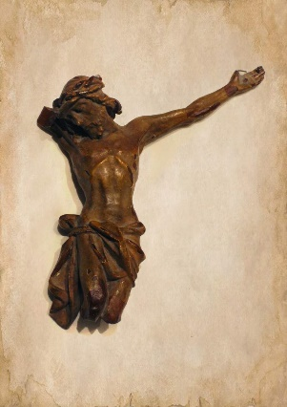
At the beginning of Lent Fr Tomaz Mavric, Superior General of the Vincentian Family sent a Lenten Letter to the Vincentian Family.
In the letter Fr Tomaz tells the story of the ‘Broken Christ’.
The figure was found by a priest who takes it home, promising to restore the figure. The priest is upset to see the figure of Christ so mutilated and wonders who could have done such a thing. Yet, when he prays about restoring the figure, he hears Christ tell him not to restore the figure as Christ sees the mutilated figure as a symbol of the pain of others, “the symbol that will cry out the pain of my second Passion in my brothers and sisters. Leave me broken! Kiss me broken!”
Throughout Fratelli Tutti, Pope Francis appeals to readers and listeners to be aware of our ‘broken’ brothers and sisters. He reminds us that, “Charity needs the light of truth that we constantly seek…. the light of reason and the light of faith [185]

Our call as Vincentians is to allow ourselves to seek the light of truth and to respond to all it leads us to, especially when it shows us things we would rather not see. In this Holy Week we hear how Jesus asks the Father to allow this cup to pass over him, but not His own will but the will of the Father be done. God’s will is done in so many ways and we must respect and honour this, even when we don’t understand it.

When we truly acknowledge our familial connection as Children of God, we begin to realise we are sisters and brothers, all God’s work of art, and it is up to the artist, the creator to decide how we should look. The Creator will use us just as he uses the figure of the Broken Christ, to bring his message of love to the world. No matter what we may look like on the outside, within every person lies the beauty and the wonder of the God who created us.

Every blessing for Easter. May God fill your hearts with His light this Eastertide so you can recognise the beauty of His face in the brokenness you see around you.

