Fratelli Tutti
An Invitation to build a world based on
Fraternity and Social Friendship
Reflection Lent Week 5

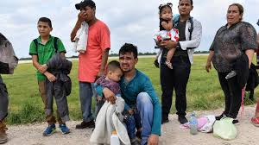
With the onset of Covid we haven’t seen so many pictures of people trying to cross the English Channel in small boats. ‘Why do they do it?’ some people ask. Others say, ‘They must be desperate to take such risks.’ Pope Francis suggests that all this unnecessary migration could be avoided if countries of origin had in place, ‘conditions for dignified life and integral development.’
But sadly, this isn’t the reality of our world. Thousands of people find it necessary to take the risk of leaving their home, their country, and in some cases their families, in order to find a place where they can live their humanity as God has created them to do.
Fratelli Tutti dedicates a whole chapter to ‘A Heart Open to the Whole world’. In this chapter Pope Francis encourages us to embrace migrants as a gift to our country, our culture, our sense of being.
He calls us to ‘Welcome, protect, promote, and integrate’ those who come seeking a new life among us. When we journey together, we learn from each other’s culture, we enrich each other and our understanding of humanity deepens.’
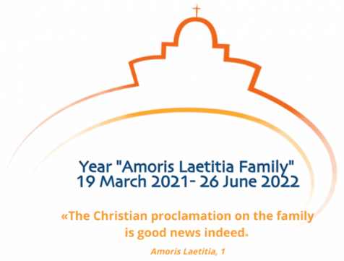
As Vincentians, a heart open to the whole world also invites us at these times, to be aware of all those around us who are in need. I spoke to a woman this morning who was a manageress in a High St clothes shop until Christmas, when she was made redundant. She has applied for financial help but hasn’t had any help so far; that’s eleven weeks with no income – not even redundancy money!
March 19th 2021 opened the ‘Year of the Family’. As a Vincentians Family, let’s embrace all God’s children as ‘family’; let’s see everyone as a sister or brother who we care for unconditionally. This way we will be living witnesses to ‘Fratelli Tutti’!
For the FamVin article on the ‘Year of the Family’, click on the link on main news page.

