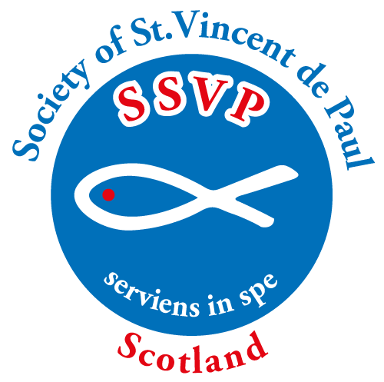
Society of St. Vincent de Paul Scotland
Resources Order Form

email to admin@ssvpscotland.com or
Post to:- Society of St. Vincent de Paul Scotland
Regent House, 113 West Regent Street
Glasgow G2 2RU

Conference Code
Conference Name
For Office Use
Date Received
Date Posted

Free Resources (+ free postage)
Prayer Cards | QTY
Conference Meeting Prayers
Daily Prayer Card for Members
‘I Live Alone’ Prayer Card
Mass Card & Envelope
Petition Prayer Card
Priced Resources
Publications | PRICE | QTY | TOTAL
Induction Booklets (free to new members) | £1.00 | **
Manual & Rule (free to new members) | £2.00 | **
Prayer Book | £2.50 | **
Blank Card - For Own Message | £0.30
Conference Books | PRICE | QTY | TOTAL
Bookkeeping Procedures for SSVP Conferences | FREE
Cash Book | £50.00
Receipt Book | £4.50
Relief Book from 1/9/23 | £40.00
Miscellaneous | PRICE | QTY | TOTAL
Children’s Prayer Card & Medal Set  (10 Pack) | £7.50
St Vincent de Paul Medal | £0.15
SSVP logo Lapel Badge | £1.00

Youth - Free Resources
Mini Vinnies (Primary School Age) | QTY
Mini Vinnie Guidebook
Badges
Pencil
Prayer Cards
Youth SSVP (Secondary School Age +) | QTY
Junior Vinnie Guidebook
Senior Vinnie Guidebook
Junior Vinnie – Badges
Senior Vinnie – Badges
Prayer Cards
Youth Induction Manuals
Pop-up Posters - Available on Loan
Please contact the national office to arrange
admin@ssvpscotland.com
Name & Address of order recipient

Totals
Cost of Resources
Cost of 2nd Class Postage*
Final Cost
* Please leave costs blank. Office staff will complete and send an invoice with the resources.

** Currently out of print - available online on website: SSVP Scotland\members\publications & resources\Publication & Resources Order Form

