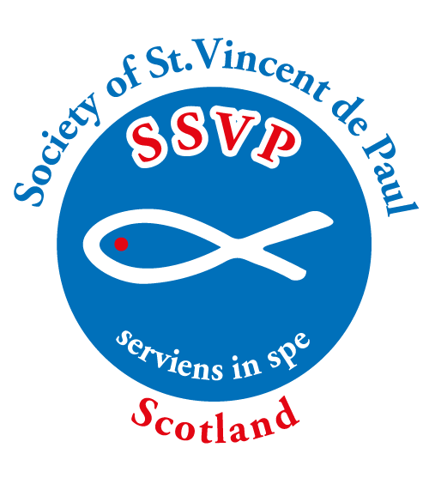

Society of St. Vincent de Paul Scotland
Application for Membership Form

SSVP Scotland Application for Membership – Privacy Notice
The information is collected to allow internal communication between SSVP Scotland members & to check PVG legal requirements. Additionally, data is invited/collected regarding gender, this is simply to allow us to assess the profile of the Society. This information will be held securely and confidentially in electronic or paper format. Following the duration of your active membership the local Conference and National Office will retain your information only as part of an archive. Your information will not be shared out with SSVP Scotland without your prior consent.
A full Privacy Notice is available from the SSVP Scotland National Office.

Conference Code
Conference Name & Town
Male/Female
Name
Address
Post Code
Home Tel. No |  |  | Mobile No.
Email Address
Date of Joining
Safeguarding | Once the Diocesan Safeguarding approval letter is issued an ID card will be issued.
 | Is PVG required? | Yes/No MembershipNumber?
 | Diocesan Safeguarding Approval Letter - Date Issued
Signature of  Member |  |  |  | Date
Signature of  Conference President |  |  |  | Date

The original form is to be retained by the Conference, and a copy sent to the National Office. Following receipt, the National Office will issue an ID card to be authorised by the President & signed by the Member.
To download copies of this form, go to: https://www.ssvpscotland.com/members/publications/

For Office Use:
ID Card No. |  | Date Issued |  | Initials
Leaving Date:

Society of St. Vincent de Paul (Scotland) is a Company Limited by Guarantee
Registered Company Number SC347803 Registered Charity SC006326
Tel. No: 0141 226 8833 Email: admin@ssvpscotland.com Web: www.ssvpscotland.com
10/2023

