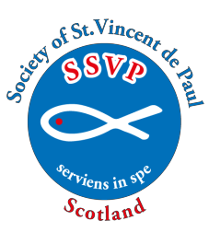

Society of St. Vincent de Paul (Scotland)
TWINNING

Application form to be
TWINNED with an Overseas Conference

Please complete the form below (retaining a copy for your own Conference records) and return to the SSVP National Office, by email or post to the address below. On receipt we will send you a Standing Order form which you should complete and give to your bank.

Conference Code:
Conference Name & Town:
Conference contact details: -
Name:
Address:
Post Code:
Email Address:

We, the Conference members, hereby promise to:
- Pray for the Twinned Conference Overseas
- Correspond with the Conference three times a year (at least once)
- Send financial support to our Overseas Twin, via the National Office, £40 per quarter by Standing Order as indicated below.
Overseas Twin | Cost per Twin  (per annum) | No. of Twins |  | Total cost  (per annum)
Indian Twin | £160
South African Twin | £160
 |  | Overall Cost
**Late payments can be made by cheque, payee SSVP (Scotland) marked TWINNING**
Conference President |  |  | Date

This form can be found on the SSVP Scotland website (www.ssvpscotland.com). Go to the website and select Members/Publications & Forms/Twinning Application Form New Twin

SSVP Scotland, Rear Second Floor, Regent House,
113 West Regent Street,
Glasgow, G2 2RU

Tel. No: 0141 226 8833 Email: admin@ssvpscotland.com Web: www.ssvpscotland.com 12/2023

