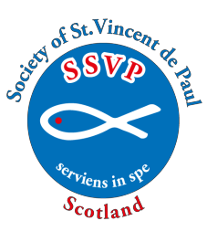

Society of St. Vincent de Paul (Scotland)
TWINNING

Application form for
STUDENT SPONSORHIP (INDIA)

Please complete the form below (retaining a copy for your own Conference records) and send to the SSVP National Office with a cheque made payable to SSVP (Scotland).

Conference Code:
Conference Name & Town:
Conference contact details:-
Name:
Address:
Post Code:
Email Address:

Type of Sponsorship | Cost per student  per year | No. of students |  | Total cost
Higher Education (HES) | £90
Technical/Vocational (TVTS) | £50
Vidya Jothi Student (VJES) | £15
 |  | Overall Cost
Conference President |  |  | Date

This form can be found on the SSVP Scotland website (www.ssvpscotland.com). Go to the website and select Members/Publications & Forms/Twinning Application Form Student Sponsorship

SSVP Scotland, Rear Second Floor, Regent House,
113 West Regent Street,
Glasgow, G2 2RU

Tel. No: 0141 226 8833 Email: admin@ssvpscotland.com Web www.ssvpscotland.com

12/2023

