VINCENTIAN REFLECTIONS
Third Quarter 2024

Liturgical Year: B

(July—August—September 2024)

Available on SVdPUSA.org



HOW TO LEAD THE VINCENTIAN REFLECTIONS IN A CONFERENCE

INTRODUCTION:
Leader describes to the group the process which is going to take place:
- Provide a copy for each member of your Conference for their personal reflection
- Stress that sharing is not compulsory and mention the need for confidentiality
- Ask, or assign, different members to read the different sections:
-Gospel reading
-Reflection
-Vincentian Meditation

OPENING PRAYER/QUIETING DOWN PERIOD
Leader invites group to:
- Become relaxed and aware of God’s presence with us
- “Let Go” of distractions and quietly pray to the Holy Spirit

READING OF THE VINCENTIAN WEEKLY REFLECTION
- Each section is read aloud, slowly and prayerfully, by the different members
- Hearing different voices will allow different emphasis on words/phrases

QUIET PERIOD
Leader invites everyone:
- To quietly reflect on the readings and notice if anything strikes them
- Introduces the Discussion Question suggested in the Reflection
- Allows 2-3 minutes of quiet – don’t hurry this. God speaks to us in the silence.

SHARING
Leader invites members who wish to share on the Discussion Question, or on how
the one of the readings struck them. Possibly not everyone will share, but time should be allowed for each person who wishes to share his/her thoughts. It is important that you resist the urge either to prod members to share, or to try to “fill the silence” with your own thoughts.

CLOSING PRAYER
Leader closes the Prayer Reflection by beginning the Closing Prayer, and all answer the response (in bold).

(This entire process should take about 10-15 minutes)
INTRODUCTION
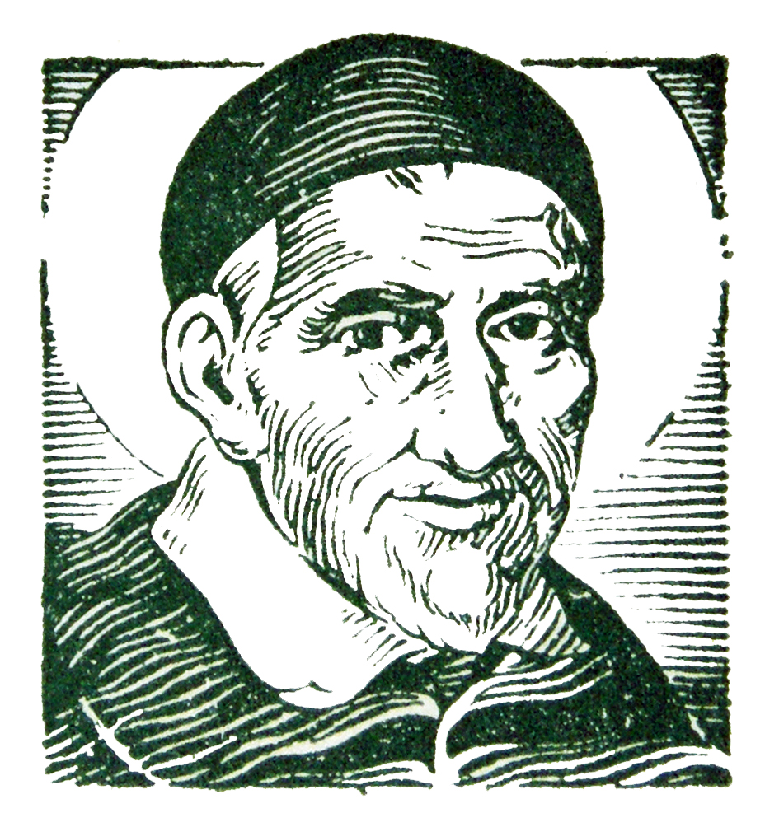
St. Vincent de Paul never wrote a book about his spiritual teachings. But we find the living voice of the saint in his letters and conferences in which he trained his followers for the mission of service to the poor.

The two fundamental sources of his teaching are the GOSPEL and LIFE. He wanted his followers to put the whole of the Gospel into the whole of their lives, and he never wearied of deepening both with all the faith that God had put into his heart. That is why all that Vincent says to us has the simplicity of our everyday life and the penetrating strength of the Word of God.

The Vincentian Weekly Reflections are therefore offered to all who strive to serve the poor in the spirit of St. Vincent de Paul. The prayer and reflections are based on the Sunday Gospel of the Liturgical Calendar, together with the feast days of some of the saints of our Vincentian Family. Each reflection offers a time for prayer, silence and discussion so that our everyday life, like Vincent, can become penetrated with the strength of the Word of God.

You may want to run copies for each member of your Conference so that they may take them home for personal reflection during the week.

LITURGICAL YEAR-Cycle B
Third Quarter-2024

JULY

July 4 Feast of Blessed Pier Giorgio Frassati
July 7 Fourteenth Sunday in Ordinary Time
July 14 Fifteenth Sunday in Ordinary Time
July 21 Sixteenth Sunday in Ordinary Time
July 28 Seventeenth Sunday in Ordinary Time

AUGUST

August 4 Eighteenth Sunday in Ordinary Time
August 11 Nineteenth Sunday in Ordinary Time
August 15 Feast of the Assumption
August 18 Twentieth Sunday in Ordinary Time
August 25 Twenty-First Sunday in Ordinary Time

SEPTEMBER

September 1 Twenty-Second Sunday in Ordinary Time
September 8 Twenty-Third Sunday in Ordinary Time
September 8 Feast of the Nativity of Mary
September 9 Feast of Blessed Frederic Ozanam
September 15 Twenty-Fourth Sunday in Ordinary Time
September 22 Twenty-Fifth Sunday in Ordinary Time
September 27 Feast of St. Vincent de Paul
September 29 Twenty-Sixth Sunday in Ordinary Time

FEAST OF BLESSED PIER GIORGIO FRASSATI
July 4

Gospel: (Matthew 11: 25-30)
Jesus exclaimed: “I give praise to you, Father, Lord of heaven and earth, for although you have hidden these things from the wise and the learned you have revealed them to little ones. Yes, Father, such has been your gracious will. …Come to me, all you who labor and are burdened, and I will give you rest. Take my yoke upon you and learn from me, for I am meek and humble of heart; and you will find rest for yourselves”.

Reflection:
Blessed Pier Giorgio Frassati was born in 1901 in Italy, and his mother taught him verses from the Gospels. Pier Giorgio was deeply moved by them and developed an exceptional relationship with God. Indeed, God reveals his love to “little ones.” From the time he was twelve until his death at twenty-four Pier Giorgio received Holy Communion daily. At 17, he joined the Society of St. Vincent de Paul and committed himself to serving the poor. Pier Giorgio said: “Jesus visits me every morning in Holy Communion. I repay him with my poor means, visiting the poor.” When asked how he could stand the bad odors and dirt of the poor, he answered: “Don’t forget that even if the house you visit is very dirty, there you may find Jesus.” The last months of his life were filled with suffering, he contracted poliomyelitis and became paralyzed. When he died, hundreds came to view his body and there was a line of unknown faces who loved this good and generous young man who always had a good smile for everyone. Pier Giorgio was beatified by Pope John Paul II on May 20, 1990. (Manual for the Society, p. 94-95)

Vincentian Meditation:
Frederic Ozanam wrote: “Help then becomes honorable, because it may become mutual, because every man who gives a kind word, a good advice, a consolation today, may tomorrow stand himself in need of a kind word, an advice, or a consolation; because the hand that you clasp clasps yours in return; because that indigent family whom you love loves you in return, and will have largely acquitted themselves toward you when the old man, the mother, the little children shall have prayed for you.” (Ramson, Praying with Frederic, p. 93)

Discussion: (Share your thoughts on the readings after a moment of silence.)
How have you found your service “honorable because it was mutual?” Give thanks for all of the “unknown faces” who pray for you.
Closing Prayer:
Inspired by Frederic and Pier Giorgio, we know that:
When we encounter the brokenness of the poor,
-Jesus will be our strength.
When the burdens of ministry overwhelm us,
-Jesus will be our strength.
When we proclaim the Gospel to the abandoned,
-Jesus will be our strength. Amen
FOURTEENTH SUNDAY IN ORDINARY TIME
July 7, 2024

Gospel: (Mark 6: 1-6)
Jesus went to his own part of the country followed by his disciples. When the Sabbath came he began to teach in the synagogue in a way that kept his audience amazed. They said: “Where did he get all this? What kind of wisdom is he endowed with? How is it that such miraculous deeds are accomplished by his hands? Isn’t this the carpenter, the son of Mary, a brother of James and Joses and Judas and Simon. Aren’t his sisters our neighbors here?” They found him too much for them. Jesus’ response to all this was: “No prophet is without honor except in his native place, among his own kindred, and in his own house.” He could work no miracle there, apart from curing a few who were sick by laying hands on them, so much did their lack of faith distress him. He made the rounds of the neighboring villages instead, and spent his time teaching.

Reflection:
“Where did this man get all this?” They saw but they didn’t believe. The challenge of this gospel is to look beyond our own knowledge of others preconditioned by what we think we know about them and listen to them, allow them to teach us about God and how to be faith-filled disciples. God does not very often visit us in the unusual and spectacular, hitting us over the head so that we don’t miss God’s message of salvation. Most often God visits us in the ordinary circumstances of our own lives through ordinary people we meet who are faithful as Jesus was to their own mission to make known the gospel. It is too easy to dismiss the events of this gospel reading as past history. After all, we like to think, if we had been there and seen those mighty deeds, we would have believed. Really? (Living Liturgy, p.168)

Vincentian Meditation:
Had we but eyes of faith, we would see that each day we are being surprised by joy. We have come to take so much that is good in life for granted. Is not your call to serve the poor a surprise, seeing that so many others are so imprisoned in themselves that their hearts remain untouched by the sufferings of the poor whom you are serving? Your unselfish service of the poor is for the poor themselves a surprise. (McCullen, Deep Down Things, p. 378)

Discussion: (Share your thoughts on the readings after a moment of silence)
How has God visited you in the ordinary circumstances of your life?

Closing Prayer:
Jesus, give us the grace to find you in the ordinary circumstances of life,
-as we learn to trust in you.
Teach us to find all the ways that you surprise us by joy,
-as we learn to have faith in you.
Teach us to be grateful for being called to serve the poor,
-as we learn to love unselfishly with you. Amen

FIFTEENTH SUNDAY IN ORDINARY TIME
July 14, 2024

Gospel: (Mark 6: 7-13)
Jesus summoned the Twelve and began to send them out two by two…He instructed them to take nothing for the journey but a walking stick—no food, no sack, no money in their belts. He said to them, “Wherever you enter a house, stay there until you leave. Whatever place does not welcome you, leave there and shake the dust from your feet in testimony against them.” So they went off and preached repentance. The Twelve drove out many demons, and they anointed with oil many who were sick and cured them.

Reflection:
Jesus sends the apostles out on mission, two by two. His instructions indicate that they are to stay focused on what they are to do. Everything they would do originates in Jesus and the power to stay focused on the mission and be successful comes only from Jesus who sent them. When disciples are sent on mission it is to take up the mission of Jesus, and there is only one mission, to establish God’s reign. Like Jesus, disciples will meet resistance, but they will also meet success when they encounter those with faith. It is an awesome thought that Jesus entrusts his mission to us. With our own power and talent, we can do little; with the authority with which Jesus invests his disciples we can do much. (Living Liturgy, p.170)
Vincentian Meditation:
The Manual of the Society states: From the beginning of the Society, the central and most basic activity of Conferences has been the visitation of the needy in the home. This action is the clearest symbol of the Vincentian charism which dictates the highest respect for the dignity of the poor…It symbolizes the fact that Vincentians are to reach out to the needy… and it is in the home environment that needy persons feel most free to entrust their stories of struggle to the helper. It is there, in the family setting, that Vincentians are asked to listen, offer humble advice, and render assistance. A related tradition is that Vincentians always visit in pairs: “two by two”. This requirement is based on the fact that the Conference is a community, not a collection of individuals who “do their own thing.” (US Manual, P.98)

Discussion: (Share your thoughts on the readings after a moment of silence)
In your home visits, how have you felt like the apostles going “two by two”—being sent to carry the mission of Jesus to the poor?

Closing Prayer:
Jesus, as we go together on home visits,
-walk with us.
Teach us to do what is right and just,
-and to speak the truth with courage.
Teach us to embrace the stranger,
-and to recognize the face of Christ.
Teach us to serve the poor with love,
-and to treasure each other in our Conference. Amen
SIXTEENTH SUNDAY IN ORDINARY TIME
July 21, 2024

Gospel: (Mark 6:30-34)
The apostles gathered together with Jesus and reported all they had done and taught. He said to them, “Come away by yourselves to a deserted place and rest a while.” People were coming and going in great numbers, and they had no opportunity even to eat. So they went off in the boat by themselves to a deserted place.

Reflection:
Last Sunday Jesus sent his apostles on mission; this Sunday they face the harsh reality that the mission will wear them out. The exhaustion can come from the good work and the “great numbers” of people who need help. The needs are great, and it can be exhausting to try to meet them. Whatever the cause of being worn out, Jesus is there to listen, support, and invite us to rest a bit. If we let Jesus gather us in, he will take care of us. We all need to go off to a “deserted place” occasionally to “rest awhile.” Whether this means taking some time alone each day to pray and rest in God, making Sunday truly a day of rest, or setting aside a few days a year to make a retreat, all of us need time to regain our strength so we can take up our own shepherding tasks. If the mission overwhelms us we will be unable to persevere. Living faithful to the mission Jesus has given us requires that we balance action and contemplation. (Living Liturgy, p.174)

Vincentian Meditation:
Vincent de Paul, a great man of action was also a contemplative, caught up in God and consumed by his love. His contemplation of God’s love overflowed into practical love for the poor. He encourages his followers: “Let us all give ourselves completely to the practice of prayer, since it is by it that all good things come to us. If we persevere, it is thanks to prayer. If we succeed in our employments, it is thanks to prayer. If we do not fall into sin, it is thanks to prayer. If we remain in charity and if we are saved, all that happens is thanks to God and thanks to prayer. Just as God refuses nothing to prayer, so also He grants almost nothing without prayer.” (Maloney, He Hears the Cry of the Poor, p. 98)

Discussion: (Share your thoughts on the readings after a moment of silence)
As a Vincentian, how can you become more like a “contemplative in action?”

Closing Prayer:
Lord, give us the grace to become “contemplatives in action
-Let our prayer rise before you.
For all those whom we have served this week,
-Let our prayer rise before you.
For all those who labor for unjust wages,
-Let our prayer rise before you.
For all those who have no work,
-Let our prayer rise before you. Amen
SEVENTEENTH SUNDAY IN ORDINARY TIME
July 28, 2024

Gospel: (John 6:1-15)
Jesus went across the Sea of Galilee. A large crowd followed him, because they saw the signs he was performing on the sick. Jesus went up on the mountain, and there he sat down with his disciples…When Jesus raised his eyes and saw that a large crowd was coming to him, he said to Philip, “Where can we buy enough food for them to eat?”… One of his disciples, Andrew, the brother of Simon Peter, said to him, “There is a boy here who has five barley loaves and two fish; but what good are these for so many?” Jesus said, “Have the people recline.” So they reclined, about five thousand in number. Then Jesus took the loaves, gave thanks, and distributed them to those who were reclining, and also as much of the fish as they wanted. When they had their fill, he said to his disciples, “Gather the fragments left over, so that nothing will be wasted.”

Reflection:
The multiplication account has more to do with what Jesus was saying about the future than about feeding a hungry crowd. The abundance is a sign of the resurrected life and points to a time of fulfillment when God’s plan for redemption is finally realized. The bread grain is specified as barley, the grain used by the poor; in the messianic reign the poor will share in God’s abundance. Jesus supersedes both the apostles’ and the crowd’s expectations: with little he feeds many…Jesus is the sign of God’s lavish presence and love. We Christians are to see our lives through the lens of God’s extravagant love. Do we? (Living Liturgy, p.178)

Vincentian Meditation:
In the Manual for the Society we read: For Vincent and Frederic, there is only one love. The love of God and the love of the neighbor are one and the same love. It is our love in response to God’s love for us. Since the loving God cannot be seen but must be experienced through loving people, it follows that one who sees others without loving cannot love or even know God. For Vincent and Frederic, as for Jesus, love is neither sentiment, nor affection, nor theory, but a practical willing of another’s best interests and a consequent striving to advance those interests. Vincentians are about loving. Love is a verb, not a noun. Vincentians are concerned with the practice and exercise of the virtue of charity…loving God above all things and our neighbor as ourselves for the love of God. (US Manual, P.26)

Discussion: (Share your thoughts on the readings after a moment of silence)
Who are the “loving people” in your life in whom you have experienced the love of God?

Closing Prayer:
Lord, draw our hearts away from selfishness,
- turn our lives to loving service.
Lord, may we bring the bread of hope to the poor,
-teach us to serve you in those who suffer.
Lord, may we come to know the abundance of your love,
-give us compassionate hearts. Amen
EIGHTEENTH SUNDAY IN ORDINARY TIME
August 4, 2024

Gospel: (John 6:24-35)
Jesus said “Do not work for food that perishes but for the food that endures for eternal life, which the Son of Man will give you. For on him the Father, God, has set his seal.” So they said to him, “What can we do to accomplish the works of God?” Jesus answered, “This is the work of God, that you believe in the one he sent.” … “I am the bread of life; whoever comes to me will never hunger, and whoever believes in me will never thirst.”

Reflection:
If Jesus is the bread from heaven given for us and we are the body of Christ, then we must conclude that we ourselves are to be bread from heaven that fosters eternal life for others. Jesus gives himself as bread from heaven. We give ourselves to others, as bread from heaven, when we confirm our belief by means of the everyday actions we do. Treating another as the body of Christ is believing. Taking time to be in touch with our spiritual needs is believing. Reaching out in compassion to others is believing. Self-giving is believing. (Living Liturgy, p.182)

Vincentian Meditation:
In your ministry, as St. Vincent says, first do and then teach. As a follower of Christ, a servant of the poor, you will touch the hearts of God’s people especially when you give vibrant witness:
• through the language of works, performing the works of justice and mercy: feeding the hungry, giving drink to the thirsty, helping to find the cause of their hunger and thirst and the ways of alleviating them;
• through the language of words, announcing with deep conviction the Lord’s presence, his love, his offer of forgiveness and acceptance to all;
• through the language of relationships, being with the poor, working with them, forming a community that shows the Lord’s love for all. (Maloney, He Hears the Cry of the Poor, p165)

Discussion: (Share your thoughts on the readings after a moment of silence)
How do we give ourselves to others as bread from heaven …in works, words and relationships?

Closing Prayer:
Lord, set our hearts on fire with compassion for the poor,
-so that we may witness to your love through our works.
Lord, fill us with your love and forgiveness,
-so that we may give ourselves to others as bread from heaven.
Lord, give us the grace to create communities of faith,
-so that we may be with and work with those who are poor.
Amen

NINETEENTH SUNDAY IN ORDINARY TIME
August 11, 2024

Gospel: (John 6:44-51)
Jesus said: “No one can come to me unless the Father who sent me draw him, and I will raise him on the last day. It is written in the prophets: They shall all be taught by God. Everyone who listens to my Father and learns from him comes to me. Not that anyone has seen the Father except the one who is from God; he has seen the Father. Amen, amen, I say to you, whoever believes has eternal life….I am the living bread that came down from heaven; whoever eats this bread will live forever; and the bread that I will give is my flesh for the life of the world.”

Reflection:
How many times does Jesus have to teach the same message before the crowd gets it? With such a great gift offered—bread from heaven that brings eternal life—we would think that the crowd would put their problems with belief aside and receive anyway, for the gift far exceeds the cost of belief. But… the bread of heaven isn’t without its cost. For Jesus, the cost is the cross. The bread of life is the bread of self-sacrifice. Here is the crux of the problem and here is the giant step forward in this gospel: to eat the bread of life is to eat the bread of suffering. To encounter Jesus by eating the bread of life is to take upon ourselves Jesus’ life of self-giving. But unlike the crowd who simply didn’t understand, we are able to believe: because Jesus has gone before us and taught us that death leads to life. The Cross leads to Resurrection! (Living Liturgy, p.186)

Vincentian Meditation:
Nothing will nourish us more than focusing on God’s love, of which the cross is the symbol. The love that Jesus reveals through the symbol of the cross is: self-giving, sacrificial, forgiving, healing, unifying, loyal to one’s friends, powerless, in solidarity with the weak, confident in the power of God. As Vincentians, frequent meditation on the cross, as the symbol of God’s love for us and of our love of God, has abiding importance. Jesus’ dying love gives meaning to the many “crosses” his followers are called to bear. The following of the crucified Lord is the supreme act of faith; it is a surrender in hope and love into the incomprehensible mystery of God. (Maloney, He Hears the Cry of the Poor, p. 45-46)

Discussion: (Share your thoughts on the readings after a moment of silence)
In what ways have you found that indeed, the cross leads to resurrection!

Closing Prayer:
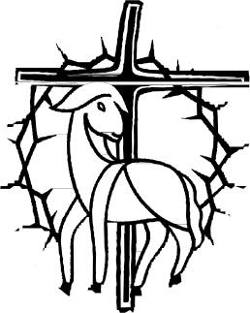Lord Jesus, through your cross and resurrection,
-fill us with your peace!
For the grace to eat the bread of life and the bread of suffering,
-fill us with your strength!
For the grace to accept the crosses in our lives,
-fill us with your love!
For the grace to be witnesses to your resurrection,
-fill us with your joy! Amen
ASSUMPTION OF THE BLESSED VIRGIN MARY
August 15, 2024

Gospel: (Luke 1:39-56)
Mary set out and traveled to the hill country in haste to a town of Judah, where she entered the house of Zechariah and greeted Elizabeth. When Elizabeth heard Mary’s greeting, the infant leaped in her womb, and Elizabeth filled with the Holy Spirit, cried out in a loud voice and said, “Blessed are you among women, and blessed is the fruit of your womb. And how does this happen to me, that the mother of my Lord should come to me? For at the moment the sound of your greeting reached my ears, the infant in my womb leaped for joy. Blessed are you who believed that what was spoken to you by the Lord would be fulfilled.”

Reflection:
Mary’s “yes” unleashed a unique relationship with Jesus. This is why all generations will call her blessed: without knowing how and why, she believed that God would raise her up to be the Mother of God. For nine months she would nurture in her womb the Life that would bring life to all. For nine months she would give her body so that the Bread of Life might be born. Mary is blessed because she believed in God’s word. Mary is blessed because her body gave life to the Word incarnate. This is why we believe that her body is assumed into heaven: hers was a blessed body. Body and soul, she was assumed into heaven to enjoy eternal life with the divine Word, her Son. And, this because she believed and trusted in God! (Living Liturgy, p.190)

Vincentian Meditation:
Mary is the ideal disciple, the model listener. She hears God’s word and acts on it. Mary, as the Listening Disciple, lies at the core of New Testament spirituality: all disciples, like Mary, are called to listen to the word of God attentively and act on it. There is almost nothing more important that Mary can teach us than to learn to listen. At root, being a disciple means being a hearer of the word. The whole of Christian life can be summed up in the phrase: “She listened to the word of God and acted on it.” (Maloney, Go! On the Missionary Spirituality of St. Vincent de Paul, p.110-111)

Discussion: (Share your thoughts on the readings after a moment of silence)
How can we better live our Vincentian devotion to Mary?

Closing Prayer:
Mary responded with joyful faith to your call,
-Lord, open our hearts to do your will.
Mary listened to the Word of God and acted on it,
-Lord, grant us the grace to follow her example.
Mary assumed into heaven, you are the Mother of the Church
-Mary, full of grace, pray for us. Amen
TWENTIETH SUNDAY IN ORDINARY TIME
August 18, 2024

Gospel: (John 6: 51-58)
Jesus said to the crowds: “I am the living bread that came down from heaven; whoever eats this bread will live forever; and the bread that I will give is my flesh for the life of the world.” The Jews quarreled among themselves, saying, “How can this man give us his flesh to eat?” Jesus said to them, “Amen, amen, I say to you, unless you eat the flesh of the Son of Man and drink his blood, you do not have life within you. Whoever eats my flesh and drinks my blood has eternal life, and I will raise him on the last day. For my flesh is true food, and my blood is true drink. Whoever eats my flesh and drinks my blood remains in me and I in him.”

Reflection:
Jesus’ invitation in giving us his flesh and blood to eat and drink is an invitation to enter into his own self-giving. Eucharist is self-giving. We can be self-giving like Jesus because through the Eucharist, the body of Christ, we become Jesus. This is why we can “remain” in Jesus—we are transformed by what we eat. Our relationship to Jesus, then becomes a relationship of indwelling, of divine life. Eucharist is both gift given and invitation to our self-giving. The mystery of Eucharist strengthens us for our daily dying and rising, our daily giving of ourselves for the sake of others so that we all might share more abundantly in divine life. (Living Liturgy, p.196)

Vincentian Meditation:
Like so many of God’s graces and blessings, which we receive from Him daily, we take them too easily as something as ordinary as the light of day. The challenge for all of us, who have the joy and privilege of receiving Communion, weekly or even daily, is to keep in our souls a sense of wonder that the Bread of Life which we eat is the same as was distributed by Our Lord to his apostles at the Last Supper. The Last Supper is going on still. Just before we receive the Body and Blood of Christ in Holy Communion, the Church reminds us that we are happy to be called to the table of the Lord. “Happy are those who are called to His supper,” for at this supper it is no ordinary bread. As we receive the host, Jesus Christ is saying to each one of us in particular: “Whoever eats my flesh and drinks my blood remains in me and I in him. (McCullen, Deep Down Things, p. 168)

Discussion: (Share your thoughts on the readings after a moment of silence)
How do you keep a “sense of wonder” for the gift of Holy Communion?

Closing Prayer:
Jesus, you are the bread that fills the longing of our hearts,
- may this bread deepen our longing for justice.
Jesus, you are the wine that satisfies our thirst for holiness,
- may this wine deepen our thirst for peace. Amen.
TWENTY-FIRST SUNDAY IN ORDINARY TIME
August 25, 2024

Gospel: (John 6: 60-69)
Many of Jesus’ disciples who were listening said, “This saying is hard; who can accept it?”… Jesus said, “It is the Spirit that gives life…the words I have spoken to you are spirit and life.” Jesus knew from the beginning the ones who would not believe and the one who would betray him. And he said, “For this reason I have told you that no one can come to me unless it is granted him by my Father.” As a result of this, many of his disciples returned to their former way of life and no longer accompanied him. Jesus then said to the Twelve, “Do you also want to leave?” Simon Peter answered him, “Master, to whom shall we go? You have the words of eternal life. We have come to believe and are convinced that you are the Holy one of God.”

Reflection:
Believing in Jesus and his teaching requires letting go of what we think we know of God and allowing God to act in a whole new way. Israel’s expectations of who the Messiah would be blocked the way for some to see God acting in a new way and offering a whole new way of relating to us. Never before had Israel heard of a God who becomes incarnate and dwells among the people. Believe or leave is a pretty clear choice. Many of us make the choice to stay with Jesus but live the new, self-giving life only halfheartedly. Liturgy invites us to constantly assess the depth of our belief-commitment. We judge our belief not on what we say or think but on what we do. Self-giving always leads to new life and this is why we are able to make the choice to stay with the Master, for we have come to know and believe that he has the words of eternal life. (Living Liturgy, p.196)

Vincentian Meditation:
In prayer, the emphasis must always be on the presence of the personal God, to whose word we must listen attentively, as he speaks to us the good news of his love for us and for others. In an era when there is much noise, where the media, if we so choose, speak to us all day long, we must ask ourselves: Are we able to distinguish the voice of God among the many voices that are speaking? Is God’s word able to say “new things” to us? Are we still capable of wonder? The word “wonder” has a kinship with the word wound. Is the word of God able to wound us, to penetrate the membrane that seals us off, that encloses us within ourselves? Can it break into our consciousness and change us? (Maloney, Go! On the Missionary Spirituality of St. Vincent de Paul, p.24)

Discussion: (Share your thoughts on the readings after a moment of silence)
How is the Holy Spirit calling us to change- to become “new”?

Closing Prayer:
Jesus is ever present with God, and ever present with us, and so we pray,
-Lord to whom shall we go? You have the words of eternal life.
We ask for strength to continue as your faithful disciples,
-and may we always let your word break into our consciousness and change us. Amen.

TWENTY-SECOND SUNDAY IN ORDINARY TIME
September 1, 2024

Gospel: (Mark 7: 1-8)
Jesus summoned the crowd again and said to them, “Hear me, all of you, and understand. Nothing that enters one from outside can defile that person; but the things that come out from within are what defile. From within people, from their hearts come evil thoughts, unchastity, theft, murder; adultery, greed, malice, deceit, licentiousness, envy, blasphemy, arrogance, folly. All these evils come from within and they defile.”

Reflection:
It’s easier to clean the pots and pans than to clean one’s heart! It’s also easy to dismiss this gospel because our tradition has never emphasized this kind of ritual impurity. Yet, the gospel hits home closer than we may think. What traditions do we blindly cling to? Perhaps it is enough for us just to go to Mass on Sunday; after all, this is what most of us grew up doing. Or perhaps we cling to rote prayers that we learned as a child rather than stretch our relationship with God to find new prayer expressions. Perhaps we relegate God in our lives to an hour on Sunday. Do we keep the letter of the law and miss entirely the spirit of the law? Interior righteousness means a heart turned to God. We need to look at the way we live, and this will tell us whether we have hearts truly turned toward God, all of the time. Purity of heart is expressed in righteous living: self-giving for the sake of others. This is how we have life. (Living Liturgy, p.200)

Vincentian Meditation:
For St. Vincent, simplicity consisted in referring things to God alone, or purity of intention. In this sense simplicity is doing everything for love of God and for no other end. It entails avoiding “human respect” or doing things merely to look good in the eyes of others. Simplicity is speaking the truth. It is saying things as they are, without concealing or hiding anything. The heart must not think one thing while the mouth says another. Vincentians must avoid all duplicity, dissimulation, cunning, and double meaning. (Maloney, He Hears the Cry of the Poor, p.144-145)

Discussion: (Share your thoughts on the readings after a moment of silence)
How do we live our core value of Simplicity in the spirit of St. Vincent?

Closing Prayer:

Through Christ, the merciful Servant,
-give us interior righteousness and a heart turned to God.
Through Christ, the Healer,
-give us the grace to always speak the truth.
Through Christ, the Holy One,
-give us the grace to avoid all duplicity, cunning and double meaning. Amen.
TWENTY-THIRD SUNDAY OF ORDINARY TIME
September 8, 2024

Gospel: (Mark 7: 31-37)
Jesus left the district of Tyre and returned by way of Sidon to the Sea of Galilee, into the district of the Ten Cities. Some people brought him a deaf man who had a speech impediment and begged him to lay his hand on him. Jesus took him off by himself away from the crowd. He put his fingers into the man’s ears and, spitting, touched his tongue; then he looked up to heaven and emitted a groan. He said to him, “Ephphatha!” that is, “Be Opened.” At once the man’s ears were opened; he was freed from the impediment, and began to speak plainly. Then he enjoined them strictly not to tell anyone; but the more he ordered them not to, the more they proclaimed it. Their amazement went beyond all bounds: “He has done everything well! He makes the deaf hear and the mute speak.”

Reflection:
In living the gospel, rather than simply bringing others to Jesus we ourselves are the presence of the risen Christ who bring healing and salvation. If we are to be the embodiment of God’s saving power then we must open our ears to hear and recognize all the everyday opportunities for making God’s presence and reign known. This might be something so simple as turning off the TV and spending some time in the family listening to each other. Or it might be something so demanding as choosing to work fewer hours, and have less money available, in order to be more present to others. However we respond to other’s needs, it is helpful to remember that we do embody God’s offer of salvation through the good we do. (Living Liturgy, p.206)

Vincentian Meditation:
St. Vincent tells us that humility is a grace of our Lord Jesus. Humility only comes when the light of Jesus penetrates deeply into our being and into all our thinking and reflection. When that light does penetrate into us, it transfigures everything, not only our opinion about ourselves but our attitude towards others. With humility God will be glorified, the poor will be served and made happy, and we ourselves will enjoy the grace and peace of Jesus Christ, who is gentle and humble of heart. (McCullen, Deep Down Things, p.586)

Discussion: (Share your thoughts on the readings after a moment of silence)
How have you brought healing and have been the “presence of Christ” to others?

Closing Prayer:
Jesus, as you opened the ears of the deaf man,
-open our ears to hear the cries of the poor.
Jesus, as you removed the speech impediment of the deaf man.
-give us the grace to speak of your love to others.
Jesus, let your light penetrate into us,
-transfiguring our opinion about ourselves and our attitude towards others. Amen

FEAST OF THE BIRTH OF MARY
September 8

Gospel: (Matthew 1: 18-32)
Suddenly the angel of the Lord appeared in a dream and said: “Joseph, son of David, have no fear about taking Mary as your wife. It is by the Holy Spirit that she has conceived this child. She is to have a son and you are to name him Jesus because he will save his people from their sins.” All this happened to fulfill what the Lord had said through the prophet: “The virgin shall be with child and give birth to a son, and they shall call him Emmanuel.”

Reflection:
Frederic Ozanam died on the feast of the Birth of the Blessed Virgin Mary, September 8, 1853. It seems fitting for this man to die on the feast of a woman to whom he had been greatly devoted all his life. Devotion to Mary, the mother of God, was part of Frederic Ozanam’s life from childhood to death. He sought her intercession often. Kneeling at her altar, he prayed, “I place my intentions under the auspices of our Divine Mother…” Frederic believed in the power of Mary, the Mother of God. He often prayed to her for himself and for others. He believed in the power of Mary’s intercession with her divine offspring. Devotion to her was woven into the various stages of Frederic’s life and especially prominent in the poetic devotion of youth, the moral challenges of young adulthood, the transformation of becoming a parent, and the acceptance of suffering and death. Frederic invites us to consider our own devotion to Mary and our trust in her intercession. (Ramson, Praying with Frederic, p.68, 71)

Vincentian Meditation:
“I am entirely yours, most Holy Virgin, that I may more perfectly belong to God. Teach me, therefore, to imitate your holy life by fulfilling the designs of God in my life. I very humbly beg you to assist me.”-St. Louise de Marillac- (Gibson and Kneaves, Praying with Louise, p. 91)

Discussion: (Share your thoughts on the readings after a moment of silence)
Have you ever felt the power of Mary, the mother of God, in your life? Do you need to ask her intercession for a significant situation now?

Closing Prayer:
O God, as we celebrate the birth of Mary,
-we ask for the grace to trust in her intercession.
Through Mary, source of our joy,
-we ask for the grace of healing the brokenhearted.
Through Mary, seat of wisdom,
-we ask for the grace of guidance in our lives.
Through Mary, mother of God,
-we ask for the grace to recognize Jesus in the poor.
Amen
FEAST OF BLESSED FREDERIC OZANAM
September 9

Gospel: (Luke 10: 25-37)
“And who is my neighbor?” Jesus replied: “There was a man going down from Jerusalem to Jericho who fell in with robbers. They stripped him, beat him, and then went off leaving him half-dead. A priest happened to be going down the same road; he saw him but continued on. Likewise there was a Levite who came the same way; he saw him and went on. But a Samaritan who was journeying along came on him and was moved to pity at the sight. He approached him and dressed his wounds, pouring in oil and wine as a means to heal. He then hoisted him on his own beast and brought him to an inn, where he cared for him. The next day he took out two silver pieces and gave them to the innkeeper with the request: “Look after him, and if there is any further expense I will repay you on my way back.” Which of these three, in your opinion, was neighbor to the man who fell in with the robbers?” The answer came, “The one who treated him with compassion.” Jesus said to him, “Then go and do the same.”

Reflection:
Frederic heard the call of Jesus –to be merciful. He saw the works of mercy as calls to action. He believed that if he genuinely wanted to serve the poor and others, he had to direct his works of mercy to the moral and spiritual betterment of individuals, not only to the alleviation of their physical distress.

Vincentian Meditation:
At Frederic Ozanam’s beatification ceremonies, August 22, 1997, Pope John Paul II told the world: “Frederic observed the real situation of the poor and sought to be more and more effective in helping them in their human development. He understood that charity must lead to efforts of justice…that charity and justice go together. Frederic had the clear-sighted courage to seek a front-line social and political commitment in a troubled time in the life of his country.” (Memorial of the Beatification of Frederic Ozanam, p.82)

Discussion: (Share your thoughts on the readings after a moment of silence)
How are you living the spirit of Frederic in “justice and charity”?
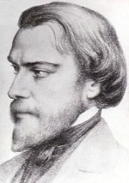
Closing Prayer: A Litany in Honor of Blessed Frederic Ozanam

Frederic Ozanam, defender of faith, pray for us.
Frederic Ozanam, promoter of hope, pray for us.
Frederic Ozanam, apostle of charity, pray for us.
Frederic Ozanam, exemplary husband and father, pray for us.
Frederic Ozanam, lover of poverty and the poor, pray for us.
Frederic Ozanam, advocate of the dignity of the human person, pray for us.
Frederic Ozanam, servant of the truth, pray for us.
Frederic Ozanam, model for Catholic teachers and professors, pray for us.
Frederic Ozanam, disciple of St. Vincent De Paul, pray for us.
Frederic Ozanam, faithful son of the Church, pray for us.
Amen

TWENTY-FOURTH SUNDAY OF ORDINARY TIME
September 15, 2024

Gospel: (Mark 8:27-35)
Jesus and his disciples set out for the villages around Caesarea Philippi. On the way he asked his disciples this question: “Who do people say that I am?” They replied, “Some, John the Baptizer, others, Elijah, still others, one of the prophets.” “And you,” he went on to ask, “who do you say that I am?” Peter answered him, “You are the Messiah!” Then he strictly ordered them not to tell anyone about him. He then began to teach them that the Son of Man had to suffer much, be rejected by the elders, the chief priests, and the scribes, be put to death, and rise three days later…He summoned the crowd with his disciples and said to them: “If a man wishes to come after me, he must deny his very self, take up his cross, and follow in my steps. Whoever would save his life will lose it, but whoever loses his life for my sake and the gospel’s will save it.”

Reflection:
The cross is exalted—honored and venerated—because it brings life. But the only way we can share in this life is believing in Jesus and taking up our own cross so that death leads to life. Believing in Jesus implies sharing in Jesus’ death as well as his resurrection. For most of us, we readily see the crosses in our lives. Perhaps the challenge of this gospel is to see beyond our crosses to glory and life. This is the challenge of the cross: to see that glory in our everyday lives. Good surrounds all of us; the cross invites us to see that good—out of pain and poverty can come a new life that has value, meaning, and purpose for self and others. (Living Liturgy, p.208)

Vincentian Meditation:
The cross is always seen in light of the resurrection. Without the resurrection, the cross remains in darkness. Also, there is no resurrection without the cross. The cross of Christ, therefore, stands with the resurrection at the center of the good news we believe in. Together, they tell us how deeply God loves us. They evangelize us. And, besides the cross of Jesus, the crosses of his members can evangelize us, too. Our lives can be transformed by the suffering love of Jesus’ followers, who fill up his sufferings in their bodies: the sick, who bear illness with courage; the grieving, who hope against hope; the dying, who clearly trust in the resurrection. The “foolishness” of the cross will be credible on our lips only if we have learned its “wisdom” from sharing in the suffering of our brothers and sisters. (Maloney, He Hears the Cry of the Poor, p. 48-49)

Discussion: (Share your thoughts on the readings after a moment of silence)
How have you been evangelized by others who bear their cross in faith and hope?

Closing Prayer: 

Jesus, you became obedient even unto death, death on the cross,
-may we help to carry the burdens of others.

Jesus, you carried your cross with faith and trust,
-may we patiently endure our own times of suffering. Amen.

TWENTY-FIFTH SUNDAY IN ORDINARY TIME
September 22, 2024

Gospel: (Mark 9:30-37)
Jesus and his disciples came to Capernaum and, once inside the house, Jesus began to ask them, “What were you arguing about on the way?” They remained silent. They had been discussing among themselves on the way who was the greatest. Then he sat down, called the Twelve, and said to them, “If anyone wishes to be first, he shall be the last of all and the servant of all.” Taking a child, he placed it in their midst, and putting his arms around it, he said to them, “Whoever receives one child such as this in my name, receives me; and whoever receives me, receives not me but the One who sent me.”

Reflection:
Jesus uses the model of a little child to illustrate his point. Children are innocent and without pretensions. They embody what “least of all” means. This also illustrates to what extent the disciple is to become the “servant of all” by receiving even the “least of all.” The total self- emptying that enables one to receive the “least of all” describes the disciple. This is how we receive Jesus—by receiving the least. No one is insignificant. (Living Liturgy, p.212)

Vincentian Meditation:
Are we really able to hear the cries of the poor, of the most oppressed: the women and children, who are often the poorest members of society; those discriminated against because of race, color, nationality, religion; the AIDS victims, who are often shunned by their families and by the physically healthy, those on the “edges of life,” the helpless infants and the helpless aged, who are unable to speak up themselves? Are we alert, “listening,” to the “signs of the times”: the increasing gap between the rich and the poor and the repeated call for justice made by the Church? (Maloney, He Hears the Cry of the Poor, p. 25-26)

Discussion: (Share your thoughts on the readings after a moment of silence)
In what ways are you challenged to be a “servant of all” by receiving the “least of all”…whose cries are the hardest to hear?

Closing Prayer:

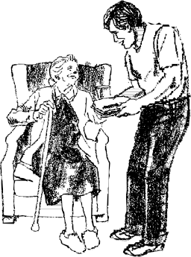Lord, set our hearts on fire with compassion for the “least of all,”
-so that we may suffer with those who suffer.
Lord, give us the grace to hear the cries of the poor,
-so that we may be a servant of the most oppressed.
Lord, help us to listen to the “signs of the times,”
-so that we may respond to the call for justice in our world. Amen
FEAST OF ST. VINCENT de PAUL
September 27

Gospel: Matthew 5:1-9
When Jesus saw the crowds he went up on the mountainside…his disciples gathered around him, and he began to teach them: “How blest are the poor in spirit: the reign of God is theirs. Blest too are the sorrowing; they shall be consoled. Blest are the lowly; they shall inherit the land. Blest are they who hunger and thirst for holiness; they shall have their fill. Blest are they who show mercy; mercy shall be theirs. Blest are the single-hearted, for they shall see God. Blest too the peacemakers; they shall be called children of God…”

Reflection:
For Vincent, love is always very concrete, very practical. It is love in practice. “Let us love God, my brothers and sisters,” he urges, “let us love God, but let it be with the strength of our arms and the sweat of our brows.” We are called to follow Christ as servants of the poor. Servants get their hands dirty. They labor long and hard. They engage in difficult tasks, visiting the sick and elderly in their homes, feeding street-people, serving the hungry, helping the widow and orphan. They are on the front lines ministering to the poor. As St. Vincent says, we must first do and then teach.

Vincentian Meditation:
St. Vincent tells us that “Love is inventive to the point of infinity.” I encourage you today to be very inventive. Because you are on the front line in laboring for the poor, you will be among the first to know their real needs. It will not be psychologists or economists, who study the needs of the poor by examining the data they receive. You will know ahead of them because the poor will tell you directly. Be inventive in meeting those needs. (Maloney, Go! On the Missionary Spirituality of St. Vincent de Paul, p.133-4)

Discussion: (Share your thoughts on the readings after a moment of silence)
In what ways can you become “inventive to infinity” in serving the needs of the poor that come to you?

Closing Prayer:
O God, your son Jesus preached the Good News to the poor,
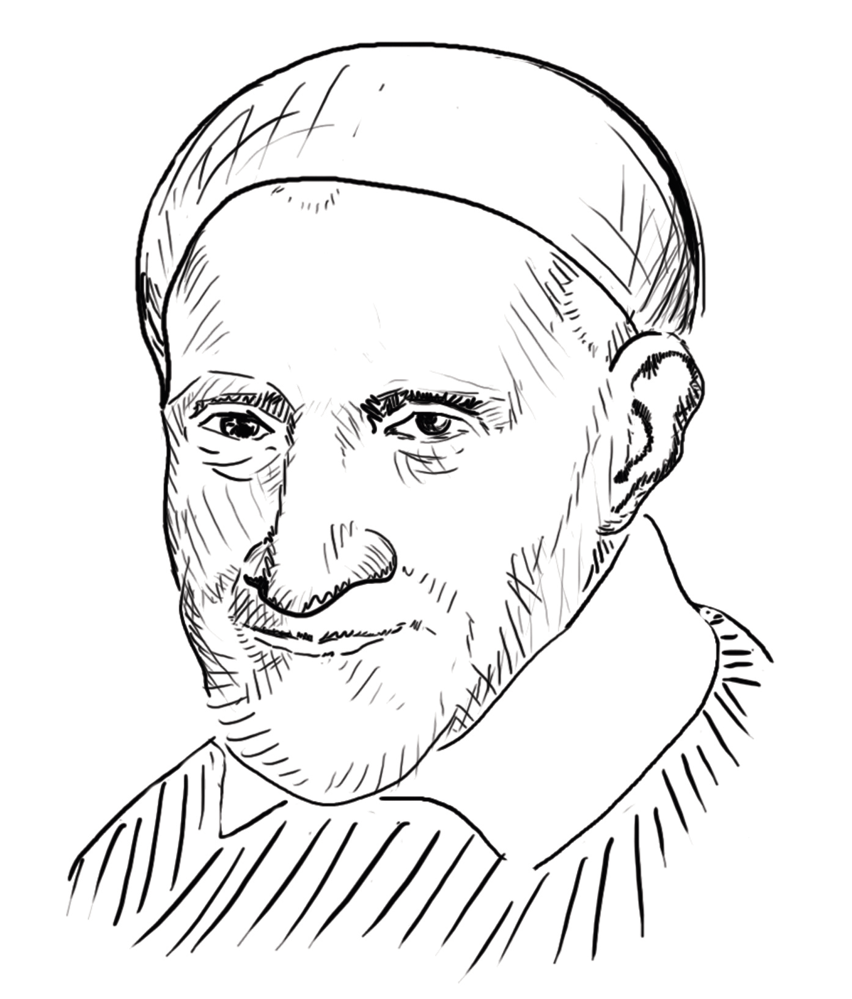-may we continue to be effective instruments of Christ to those most in need.
O God, give us the strength and creativity we need to stand in solidarity with those who suffer,
-may our hearts be filled with compassion and love.
O God, you call us to be followers of St. Vincent de Paul,
-grant us the grace to be “inventive to infinity” in serving the poor and suffering! Amen

TWENTY-SIXTH SUNDAY IN ORDINARY TIME
September 29, 2024

Gospel: (Mark 9: 38-48)
John said to Jesus, “Teacher, we saw a man using your name to expel demons and we tried to stop him because he is not of our company.” Jesus said in reply: “Do not try to stop him. No man who performs a miracle using my name can at once speak ill of me. Anyone who is not against us is with us. Anyone who gives you a drink of water because you belong to Christ will not, I assure you, go without his reward. But it would be better if anyone who leads astray one of these simple believers were to be plunged in the sea with a great millstone fastened around his neck.”

Reflection:
We often have strict, legitimate criteria for who can belong or not. In this gospel the apostle John is bringing to Jesus’ attention that someone who “doesn’t belong” was doing what Jesus did. Jesus lays down a simple, clear rule: anyone who is doing good in Jesus’ name cannot also speak ill of Jesus. Jesus has a simple rule for who belongs in his company—“whoever is not against us is for us.” This is a contrast between generous leadership and petty discipleship. Jealousy and pettiness thwart the advancement of God’s kingdom and they must be cut out. Jesus keeps us focused on what is essential: God’s kingdom. (Living Liturgy, p.218)

Vincentian Meditation:
It is difficult to see Christ in the poor. Sometimes, it is even more difficult to see him in someone in our own Conference. Our Lord keeps saying to us: If you find it difficult to see Christ in the poor or in the person who annoys you in your own Conference, begin by trying to be Christ to such people: to say nothing, to do nothing which Christ would not say or do. That calls for faith. Let us not be discouraged at our failures in our service of the poor or by our failures in fraternal charity. With the grace of Jesus Christ we must keep trying. (McCullen, Deep Down Things, p. 444)

Discussion: (Share your thoughts on the readings after a moment of silence)
Does “jealousy and pettiness” exist in our Conference…how can we change?

Closing Prayer:
For the grace to be true Vincentians, we pray:
-Lord, help us to find you in the poor and in each other.
For the grace to be open and honest with each other,
-Lord, heal our jealousy and pettiness.
For the grace to let go of our prejudice and judgmental attitudes,
-Lord, teach us how to forgive each other. Amen

