VINCENTIAN REFLECTIONS
Third Quarter 2025

Liturgical Year: C

(July – August - September)

Available on SSVPUSA.org



THE VINCENTIAN REFLECTIONS IN A CONFERENCE

INTRODUCTION:
Leader describes to the group the process which is going to take place:
- Provide a copy for each member of your Conference for their personal reflection
- Stress that sharing is not compulsory and mention the need for confidentiality
- Ask, or assign, different members to read the different sections:
-Gospel reading
-Reflection
-Vincentian Meditation

OPENING PRAYER/QUIETING DOWN PERIOD
Leader invites group to:
- Become relaxed and aware of God’s presence with us
- “Let Go” of distractions and quietly pray to the Holy Spirit

READING OF THE VINCENTIAN WEEKLY REFLECTION
- Each section is read aloud, slowly and prayerfully, by the different members
- Hearing different voices will allow different emphasis on words/phrases

QUIET PERIOD
Leader invites everyone:
- To quietly reflect on the readings and notice if anything strikes them
- Introduces the Discussion Question suggested in the Reflection
- Allows 2-3 minutes of quiet – don’t hurry this. God speaks to us in the silence.

SHARING
Leader invites members who wish to share on the Discussion Question, or on how the one of the readings struck them. Possibly not everyone will share, but time should be allowed for each person who wishes to share his/her thoughts. It is important that you resist the urge either to prod members to share, or to try to “fill the silence” with your own thoughts.

CLOSING PRAYER
Leader closes the Prayer Reflection by beginning the Closing Prayer, and all answer the response (in bold).

(This entire process should take about 10-15 minutes)
INTRODUCTION
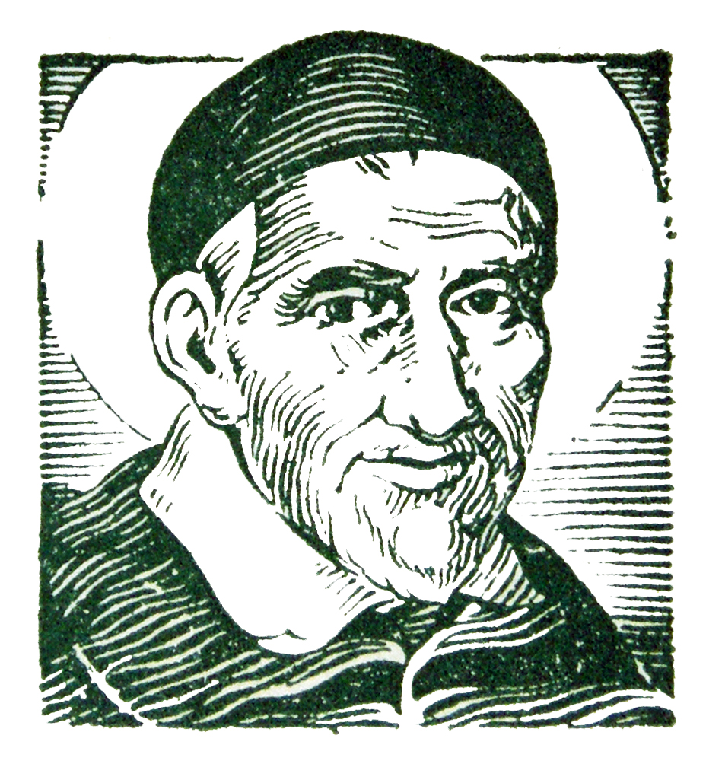
St. Vincent de Paul never wrote a book about his spiritual teachings. But we find the living voice of the saint in his letters and conferences in which he trained his followers for the mission of service to the poor.

The two fundamental sources of his teaching are the GOSPEL and LIFE. He wanted his followers to put the whole of the Gospel into the whole of their lives, and he never wearied of deepening both with all the faith that God had put into his heart. That is why all that Vincent says to us has the simplicity of our everyday life and the penetrating strength of the Word of God.

The Vincentian Weekly Reflections are therefore offered to all who strive to serve the poor in the spirit of St. Vincent de Paul. The prayer and reflections are based on the Sunday Gospel of the Liturgical Calendar, together with the feast days of some of the saints of our Vincentian Family. Each reflection offers a time for prayer, silence, and discussion so that our everyday life, like Vincent, can become penetrated with the strength of the Word of God.

You may want to run copies for each member of your Conference so that they may take them home for personal reflection during the week.

LITURGICAL YEAR C

Third Quarter - 2025

JULY
July 4 Feast of Blessed Pier Giorgio Frassati
July 6 Fourteenth Sunday in Ordinary Time
July 13 Fifteenth Sunday in Ordinary Time

July 20 Sixteenth Sunday in Ordinary Time
July 27 Seventeenth Sunday in Ordinary Time

AUGUST
August 3 Eighteenth Sunday in Ordinary Time

August 10 Nineteenth Sunday in Ordinary Time

August 15 Assumption of the Blessed Virgin Mary

August 17 Twentieth Sunday in Ordinary Time

August 24 Twenty-first Sunday in Ordinary Time

August 31 Twenty-second Sunday in Ordinary Time

SEPTEMBER

September 7 Twenty-third Sunday in Ordinary Time

September 9 Feast of Blessed Frederic Ozanam

September 14 Feast of the Exaltation of the Cross

September 21 Twenty-fifth Sunday in Ordinary Time

September 27 Feast of St. Vincent de Paul

September 28 Twenty-sixth Sunday in Ordinary Time

FEAST OF BLESSED* PIER GIORGIO FRASSATI
July 4
Gospel: (Matthew 11: 25-30)
Jesus exclaimed: “I give praise to you, Father, Lord of heaven and earth, for although you have hidden these things from the wise and the learned you have revealed them to little ones. Yes, Father, such has been your gracious will. …Come to me, all you who labor and are burdened, and I will give you rest. Take my yoke upon you and learn from me, for I am meek and humble of heart; and you will find rest for yourselves”.
Reflection:
Blessed Pier Giorgio Frassati was born in 1901 in Italy. His mother taught him verses from the Gospels, and Pier Giorgio deeply moved by them, developed an exceptional relationship with God. Indeed, God reveals his love to “little ones.” From the time he was twelve until his death at twenty-four Pier Giorgio received Holy Communion daily. At 17, he joined the Society of St. Vincent de Paul and committed himself to serving the poor. Pier Giorgio said: “Jesus visits me every morning in Holy Communion. I repay him with my poor means, visiting the poor.” When asked how he could stand the bad odors and dirt of the poor, he answered: “Don’t forget that even if the house you visit is very dirty, there you may find Jesus.” The last months of his life were filled with suffering, he contracted poliomyelitis and became paralyzed. When he died, hundreds came to view his body and there was a line of unknown faces who loved this good and generous young man who always had a good smile for everyone. Pier Giorgio was beatified by Pope Saint John Paul II on May 20, 1990. (The Manual, p.91)
Vincentian Meditation:
“Help then becomes honorable, because it may become mutual, because every one who gives a kind word, a good advice, a consolation today, may tomorrow stand themselves in need of a kind word, an advice, or a consolation; because the hand that you clasp clasps yours in return; because that indigent family whom you love loves you in return, and will have largely acquitted themselves toward you when the old man, the mother, the little children shall have prayed for you.” (Ramson, Praying with Frederic, p. 93)
Discussion: (Share your thoughts on the readings after a moment of silence.)
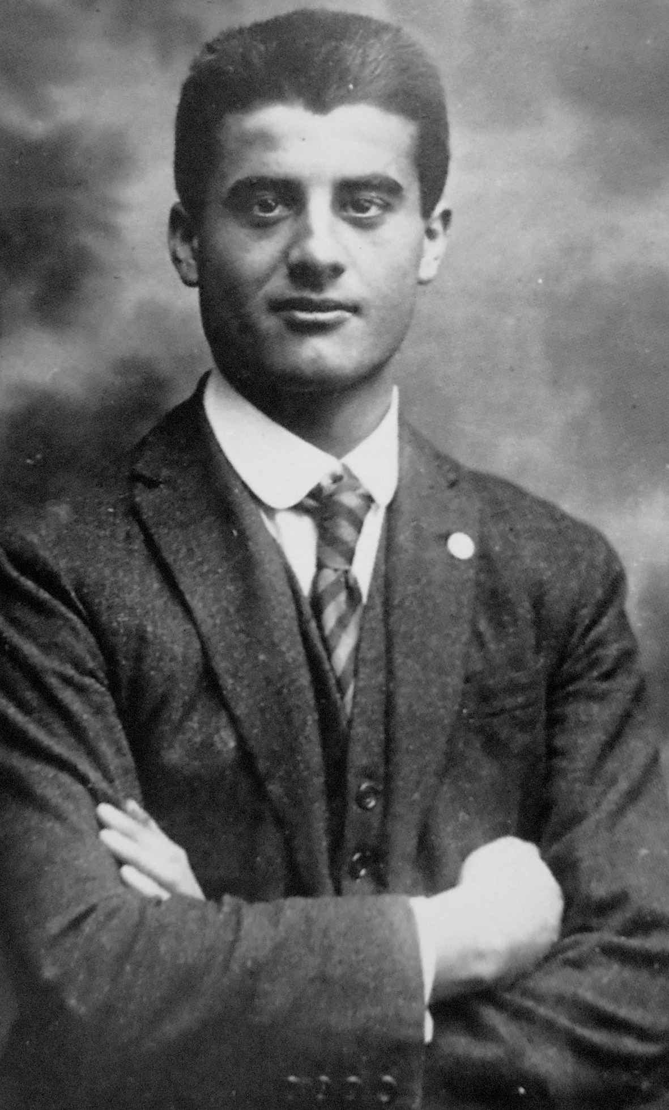How you have found Jesus in the homes of the poor?
Closing Prayer:
Inspired by Frederic and Pier Giorgio, we know that:
When we encounter the brokenness of the poor,
Jesus will be our strength.
When the burdens of ministry overwhelm us,
Jesus will be our strength.
When we proclaim the Gospel to the abandoned,
Jesus will be our strength.
Amen

* To be canonized Saint Pier Giorgio Frassati in August 2025
FOURTEENTH SUNDAY IN ORDINARY TIME

July 6, 2025
Gospel: (Luke 10:1-12,17-20)
At that time the Lord appointed seventy-two others whom he sent ahead of him in pairs to every town and place he intended to visit. He said to them, “The harvest is abundant but the laborers are few; so ask the master of the harvest to send out laborers for his havest. Go on your way ; behold I am sending you like lambs among wolves. Carry no money bag, no sack, no sandals; and greet no one along the way…Whatever town you enter and they welcome you, eat what is set before you, cure the sick in it and say to them, ‘The kingdom of God is at hand for you.’”
Reflection:
In the gospel the disciples are “sent ahead” of Jesus, not so much with a mission to do as to be ambassadors for Jesus. The respect and honor that are due Jesus are extended also to Jesus’ disciples and this is how God’s kingdom is “at hand.” When God’s kingdom is present there is peace and healing. We do everything because we are disciples of Jesus and act in his name. It is in Christ’s presence through us that peace and joy are spread. Mission is being sent to be Christ for others. (Living Liturgy, p.168)
Vincentian Meditation:
“I am sure that many of you have discovered in your work for the poor that, while their material needs are often great, their spiritual needs may be greater still. I am sure, too, that many of you have discovered that on many occasions, when the poor present a problem to you or seek your advice, you come eventually to realize that their real need is not your advice, but rather the sympathy of your listening heart. Often I feel that I have given advice to people when what they were really asking for was understanding and compassion. They were seeking a listening heart rather than a speaking bureau of information.” (McCullen, Deep Down Things,p. 538-9)
Discussion: (Share your thoughts on the readings after a moment of silence.)
How have you found that your service indeed demands a “listening heart?”
Closing Prayer:
O God, give us the grace to be your disciples:
When the poor are lonely,
may we bring your presence.
When the poor are burdened by worries,
may we bring comfort in your love.
When the poor are sick or in pain,
may we bring your healing and strength.
When the poor come to us,
may they find a listening heart.

Amen

FIFTEENTH SUNDAY IN ORDINARY TIME
July 13, 2025
Gospel: (Luke 10:25-37)
There was a scholar of the law who stood up to test Jesus and said…“And who is my neighbor?” Jesus replied, “A man fell victim to robbers as he went down from Jerusalem to Jericho. They stripped him and went off leaving him half- dead. A priest happened to be going down that road, but when he saw him, he passed by on the opposite side. Likewise a Levite came to the place, and when he saw him, he passed by on the opposite side. But a Samaritan traveler who came upon him was moved with compassion at the sight. He approached the victim, poured oil and wine over his wounds and bandaged them. Then he lifted him up on his own animal, took him to an inn, and cared for him. The next day he took out two silver coins and gave them to the innkeeper with the instruction, “Take care of him. If you spend more than what I have given you, I shall repay you on the way back.” Which of these three, in your opinion, was neighbor to the robbers’ victim?” He answered, “The one who treated him with mercy.” Jesus answered, “Go and do likewise.”
Reflection:
Jesus responds to the lawyer’s question with a parable that illustrates how keeping the law isn’t a matter of focusing on details regarding right or wrong or personal gain, but is a matter of right of right relationships with one’s neighbor as exhibited by acting with compassion and mercy. The Samaritan in the parable isn’t moved to help the stricken traveler because of the law but because he was a person of compassion and mercy. This is the law written within our hearts—not details about keeping specific laws but a general regard for the other that arises out of genuine care for the other. (Living Liturgy, p.172)
Vincentian Meditation:
“There are scripture scholars who say that there is a very subtle twist to the end of the parable. Jesus asks the lawyer: “Which of these three, in your opinion, was neighbor to the man who fell in with robbers?” The answer came, “The one who treated him with mercy.” It would seem that in asking the lawyer that question, Jesus was saying equivalently to him, “You asked Me ‘who was my neighbor?’ That was not a good question. The question you should have asked me was: “To whom can I BE neighbor? And the answer to that question is, ‘the first poor person you meet on the road.’” (McCullen, Deep Down Things, p. 141)
Discussion: (Share your thoughts after a moment of silence)
As a Conference “To whom can we BE neighbor?”
Closing Prayer:
Lord, give us the grace to love you with all our heart, with all our being, with all our strength, and with all our mind, and our neighbor as our self. Amen

SIXTEENTH SUNDAY IN ORDINARY TIME
July 20, 2025
Gospel: (Luke 10:38-42)
Jesus entered a village where a woman whose name was Martha welcomed him. She had a sister named Mary who sat beside the Lord at his feet listening to him speak. Martha, burdened with much serving, came to him and said, “Lord, do you not care that my sister has left me by myself to do the serving? Tell her to help me.” The Lord said to her in reply, “Martha, Martha, you are anxious and worried about many things. There is need of only one thing. Mary has chosen the better part and it will not be taken from her.”
Reflection:
Martha’s hospitality was made edgy because of her becoming burdened with the cooking and serving. Martha is settling to be a servant where Jesus is looking for disciples. Mary’s hospitality was gracious because she focused her attention on Jesus: “she sat beside the Lord at his feet listening to him speak.” The surprise is that Jesus affirms that the “better part” is to sit and listen—both metaphors for discipleship. The “better part” is to be a disciple! Before we can carry on the mission of Jesus as disciples, we must become disciples by sitting at the feet of Jesus listening to him. Practically speaking, this means being attentive to the Scriptures during Mass. It also means taking the time to be with Jesus in prayer—not just saying prayers but being quiet and listening to how Jesus speaks to our hearts. (Living Liturgy, p.176)
Vincentian Meditation:
“Have you noticed that there is no rejection of Martha, no suggestion that she should not have been engaged in preparing the meal? Jesus merely underlines a truth that St. Luke records earlier, namely, that they are blessed who hear the word of God and keep it. He is putting emphasis on a sense of attention to the word of God, if we are to offer that service to others which is the fulfillment of the second great commandment of the law. Hearing the word of God in prayer through reflection is a condition for true selfless loving service of the body of Christ.” (McCullen, Deep Down Things, p. 298)
Discussion: (Share your thoughts after a moment of silence)
In our Conference how can we become disciples more like Mary ?
Closing Prayer:
Lord, show us the way to be disciples who “sit and listen,”
Spirit of God, show us the way.

When we suffer with those who suffer,
Spirit of God, show us the way.
When we hear the cries of the hungry,
Spirit of God, show us the way.
When we meet the broken-hearted.
Spirit of God, show us the way.
Amen

SEVENTEENTH SUNDAY IN ORDINARY TIME
July 27, 2025
Gospel: (Luke 11:1-13)
Jesus was praying in a certain place, and when he had finished, one of his disciples said to him, “Lord, teach us to pray as John taught his disciples.” Jesus said to them, “When you pray, say: Father, hallowed be your name, your kingdom come. Give us each our daily bread and forgive us our sins for we ourselves forgive everyone in debt to us, and do not subject us to the final test.”
Reflection:
Jesus teaches us that in our prayer God is our “Father” and just as a parent’s love for their children is unlimited, so is God’s love and care for us unlimited. Jesus further teaches that prayer unfolds in the context of this special relationship of “Our Father,” it is not a kinship or progeny. “Father” is a metaphor used to describe our unique, intimate relationship with God. This relationship inspires us in us confidence with the realization that what we pray for is not so important as the fact that we address God in such intimate terms. Prayer always deepens our relationship with God and this is already an answer to what we need. (Living Liturgy, p.180)
Vincentian Meditation:
“St. Teresa of Avila often could not finish the “Our Father” because she found that the first few words said everything. What a rich word, “Father.” It brings to our minds what our own human fathers have done for us. When you say “father,” you think of one who provides, and the great provider for us all is God: “Our Father, Who is in heaven.” We can see many things wrong with the world, but it is good to think of what is right in the world. Who made the sun to rise this morning? Who gives us the fruits of the earth and the rains to soften the soil? Who feeds the birds of the air and clothes the lilies of the field? God, our Father. We could continue making a long list of the good and beautiful things we can see with our eyes or hear with our ears in this world of ours, and all of them have come from God: Our Father, Who is in heaven. Who told us all this? Jesus Christ. There are people who say that the most important truth that Jesus has taught us in the Gospels is that we have a Father in heaven and He is God.” (McCullen, Deep Down Things, p. 471-2)
Discussion: (Share your thoughts after a moment of silence)

How have you found in your life that indeed God is your “Father?”
Closing Prayer:
With longing hearts we pray,
God our Father, hear our prayer.
For those afflicted in body and spirit,
God our Father, hear our prayer.
For those searching for a place to call home,
God our Father, hear our prayer.
For those seeking for a God to believe and trust in,
God our Father, hear our prayer.
Amen

EIGHTEENTH SUNDAY IN ORDINARY TIME

August 3, 2025
Gospel: (Luke 12:13-21)
Jesus said to the crowd, “Take care to guard against all greed, for though one may be rich, one’s life does not consist of possessions.” Then he told them a parable: “There was a rich man whose land produced a bountiful harvest. He asked himself, ‘What shall I do, for I do not have space to store my harvest?’ And he said, ‘This is what I shall do: I shall tear down my barns and build larger ones. There I shall store all my grain and other goods and I shall say to myself, “Now as for you, you have so many good things stored up for many years, rest, eat, drink and be merry!’” But God said to him, ‘You fool, this night your life will be demanded of you; and the things you have prepared, to whom will they belong?” Thus it will be for all who store up treasure for themselves but are not rich in what matters to God.”
Reflection:
The rich man in the parable would have had enough in his present storehouses; seeking more, he builds more storehouses only to die and not enjoy his abundance anyway. We work hard for what we think is important to us, but we may end up with nothing because we have missed the whole point: life. We tend to think we can provide for our own future, but the gospel reminds us that the future is God’s. What we struggle all our lives to learn is that life does not consist of possessions nor our perceived security, but of being possessed by God. We belong to God and God can demand an accounting of us at any time. The only security we truly possess is a loving relationship with God. (Living Liturgy, p.184)
Vincentian Reflection:
“We as followers of St. Vincent must not forget the emphasis which he put on the virtue of simplicity. Simplicity is speaking and acting always with God alone in view. God is touching our lives at every moment of the day, and we are touching Him. He is particularly close to us in the Church, in the Sacraments and in the poor. If we wish to be sensitive to the presence of God in our lives, we have to recall His presence frequently. We have to give ourselves moments of stillness and reflection in the midst of our work and our lives, so that we can become more conscious that it is in God that we live and move and have our being at all times.” (McCullen, Deep Down Things, p. 427)
Discussion: (Share your thoughts after a moment of silence)
How have you learned that life does not consist of possessions but in knowing that it is in God that we live and move and have our being?
Closing Prayer:
Lord, keep our hearts clean and our vision clear,
as you mold us into authentic witnesses of your love.
Lord, keep our hearts clean and our vision clear,
so that we may be free from greed and selfishness.
Lord, keep our hearts clean and our vision clear,
as you renew us with the truth of your Gospel.
Amen

NINETEENTH SUNDAY IN ORDINARY TIME
August 10, 2025
Gospel: (Luke 12:32-48)
Jesus said to his disciples:“ Do not be afraid any longer, little flock, for your Father is pleased to give you the kingdom. Sell your belongings and give alms. Provide money bags for yourselves that do not wear out, an inexhaustible treasure in heaven that no thief can reach nor moth destroy. For where your treasure is, there also will your heart be”
Reflection:
Our “treasure” is something very valuable or our most prized possession. This gospel refers to “treasure” as inexhaustible, secure and incorruptible. This description is of the “treasure” understood as the kingdom God. Interestingly, the way to possess this treasure is not by possessing, but by giving away. We become rich, by not having and then refocusing our hearts on God’s kingdom. If we are preoccupied by possessions, schedules, work, sports, etc., our heart is already filled with exhaustible, insecure, and corruptible matters. The challenge of this gospel is to redirect our hearts to what is our true treasure, Jesus, and then be faithful disciples. The gift is great. Our treasure is Jesus. (Living Liturgy, p.188)
Vincentian Meditation:
“What we as Christians have to watch could be expressed in one word, and that word is more. We always seem to want more money, more pleasure, more power, and it is desiring more that can draw us away from Christ and make us unhappy people. So if we have sufficient food for ourselves, our families, and reasonable comfort in our homes, let us be content. Let us spare a thought and some money for those who, unlike us, are suffering from extreme poverty. Thus we will be able to redirect our hearts to what is our true treasure, Jesus, and then we will be faithful disciples.” (McCullen, Deep Down Things, p. 195)
Discussion: (Share your thoughts after a moment of silence)
How does this Gospel challenge us?
Closing Prayer:
Lord Jesus, may you always be our treasure,
fill us with your peace!
Lord Jesus, may you always be our treasure,
fill us with your strength!
Lord Jesus, may you always be our treasure,
fill us with your love!
Lord Jesus, may you always be our treasure,
fill us with your joy!
Amen

TWENTIETH SUNDAY IN ORDINARY TIME

August 17, 2025
Gospel: (Luke 12:49-53)
Jesus said to his disciples: “I have come to set the earth on fire, and how I wish it were already blazing! There is a baptism with which I must be baptized, and how great is my anguish until it be accomplished! Did you think that I have come to establish peace on the earth? No, I tell you, but rather division. From now on a household of five will be divided three against two and two against three; a father will be divided against his son and a son against his father, a mother against her daughter and a daughter against her mother… ”
Reflection:
In this gospel, Jesus is shocking! Jesus has a fire for accomplishing his mission and is single-minded in doing so. His very message is divisive because it calls others to a radical way of living—self-giving for the good of others. We must make a choice to follow him, to choose to speak God’s word and preach the values consistent with God’s reign. Divisions occur simply by being faithful to God’s message. This is the real shock value of the gospel: being a faithful disciple of Jesus will instigate a clash of values, of principles, of priorities. This choice can result in divisions, even within families, because all us do not make the same choice to follow Jesus. (Living Liturgy, p.194)
Vincentian Meditation:
“On the journey of life, we must make choice. Our instincts, our selfishess, our pride will
Often suggest to us to follow them. It is an easier road. But Christ, His Church and our consciences suggest another way. To follow that road, we must say no to our natural instincts. It may be difficult and demand much effort, but that effort will bring with it a peace and contentment that money will not buy.” (McCullen, Deep Down Things, p. 589)
Discussion: (Share your thoughts after a moment of silence)
What difficult choices have you made that led to a peace and contentment?
Closing Prayer:
Lord Jesus, bless us this day,
with the courage to follow you.
Lord Jesus, bless us this day,

with willingness to forgive those who hurt us.
Lord Jesus, bless us this day,
with the strength to care for the poor.
Lord Jesus, bless us this day,
with the faith to live our convictions.
Amen

ASSUMPTION OF THE BLESSED VIRGIN MARY
August 15
Gospel: (Luke 1:39-56)
Mary set out and traveled to the hill country in haste to a town of Judah, where she entered the house of Zechariah and greeted Elizabeth. When Elizabeth heard Mary’s greeting, the infant leaped in her womb, and Elizabeth filled with the Holy Spirit, cried out in a loud voice and said, “Blessed are you among women, and blessed is the fruit of your womb. And how does this happen to me, that the mother of my Lord should come to me? For at the moment the sound of your greeting reached my ears, the infant in my womb leaped for joy. Blessed are you who believed that what was spoken to you by the Lord would be fulfilled.
Reflection:
Mary is remembered because she was the first disciple to whom God did great things, lifting her up from among the lowly. Mary belongs so completely to God that even her body is at God’s disposal. Mary’s “Assumption” is a festival of mercy: Mary “returned to her home” when she completed her mission of being an instrument of God’s promise, a home which is to be with God for all eternity. The “Assumption” is a sign of God’s mercy being fulfilled. It is also a sign that our true home is with God. (Living Liturgy, p.192)
Vincentian Meditation:
“True dedication to the service of the poor goes hand in hand with the gift of availability. It was precisely because Mary had this gift of availability, this spiritual agility, that she was able to go “in haste” into the formidable hill country of Judea to visit and assist her cousin Elizabeth in giving birth to John the Baptist. In one word, the gift of availability enables us to walk on the pilgrim way with lightness in our step. The journey of Mary from Galilee to Judea tells us something of the physical strength and endurance of the Mother of God. But it is the inner spiritual strength that sustained Mary on her pilgrimage of faith. The Vatican Council document Lumen Gentium presents our Lady as a pilgrim who has already reached the heavenly Jerusalem and, because she is glorified both in body and soul in heaven, she is a special source of hope and encouragement to us who are still on the pilgrim’s road.” (McCullen, Deep Down Things,p.185-6)
Discussion: (Share your thoughts after a moment of silence)
How can we better live our Vincentian call to be available to the poor?
Closing Prayer:
For victims of terrorism and violence,
May Mary’s Assumption sustain our hope.
For an end to the oppression of those without power,
May Mary’s Assumption sustain our hope.
For all who seek to transform an unjust society,
May Mary’s Assumption sustain our hope.
Amen

TWENTY-FIRST SUNDAY IN ORDINARY TIME

August 24, 2025
Gospel: (Luke 13:22-30)
Jesus passed through towns and villages, teaching as he went and making his way to Jerusalem. Someone asked him, “Lord, will only a few people be saved? He answered them, “Strive to enter through the narrow gate, for many, I tell you, will attempt to enter but will not be strong enough….For behold, some are last who will be first, and some are first who will be last.
Reflection:
Jesus’ answer to the question is couched in images: Making his way to Jerusalem—Jesus is being faithful to his own mission, by going to Jerusalem he fulfills his Father’s will even when that means he must suffer and die. Narrow gate—we might see Jesus himself as the gate, and we are saved by identifying ourselves with Jesus and this includes going to Jerusalem with him even when that means we, too, must die to ourselves. Strong enough—strength here isn’t the physical strength to push open a literal door but the spiritual strength to remain faithful to our call to discipleship and to follow Jesus to Jerusalem. Each day we must take up our cross, die to self, and live for the sake of others. This is how we enter the narrow gate and how we get to know Jesus intimately enough to receive salvation: we must live and act like Jesus. Becoming least is a metaphor for dying to self; this is what Jesus asks: that the first become last. (Living Liturgy, p.196)
Vincentian Meditation:
“Learning to bear the beams of God’s love, as they shine through the personality of the living Christ, is the work of our lives. His experience of suffering and dying on the Cross is there to remind us that, for one who lives in a world that is enveloped by the clouds and fog of sin, the learning process will at times be a painful one. We are called to bear the beams of God’s love in our personal lives. The events of our lives, so inscrutable, so perplexing, so painful at times, are slowly strengthening us, if we could but see them with the eyes of faith, to look steadily one day at the open face of God, Who is a consuming fire of love. We are also called to refract the beams of God’s love for the poor. We are called, not to stand immobile before the mystery of suffering that we find in so many poor, hungry, lonely, homeless, wandering people, but to break down for them through our service of them, the strong light of God’s love so that they, too, can learn to bear the beams of God’s love.” (McCullen, Deep Down Things, p. 368-9)
Discussion: (Share your thoughts after a moment of silence)
As Vincentians, how have we been called to live and act like Jesus?
Closing Prayer:
Lord Jesus, you suffered death that we might live.
You are the savior of the world.
Your death brought life to the world,
may we live no longer for ourselves but for you.
Your death brought life to the world,
may we help the poor find the beams of God’s love.
Amen.

TWENTY-SECOND SUNDAY IN ORDINARY TIME
August 31, 2025
Gospel: (Luke 14:1,7-14)
Jesus said to them, “When you are invited, go and take the lowest place so that when the host comes to you he may say, ‘My friend, move up to a higher position.’ Then you will enjoy the esteem of your companions at the table. For everyone who exalts himself will be humbled, but the one who humbles himself will be exalted.” Then he said to the host who had invited him, “When you hold a lunch or a dinner, do not invite your friends or your brothers or sisters, or your relatives or your wealthy neighbors, in case they may invite you back and you have repayment. Rather, when you hold a banquet, invite the poor, the crippled, the lame, and the blind; blessed indeed will you be because of their inability to repay you. For you will be repaid at the resurrection of the righteous.
Reflection:
Humility is recognizing that by God’s choosing us we are raised up to share in divine riches and bestowed with the great dignity of sharing in God’s life. If this is how God relates to us, then this is how the disciple relates to others. As God has bestowed dignity on us, so do we shower others with dignity. If we wish God to invite us to the divine banquet, then we also extend ourselves to all others regardless of social, economic, religious, or cultural status. Before disciples can be hosts to the poor and disadvantaged they must humbly recognize themselves as those who have received a place of honor at God’s banquet table. Humility is recognizing that we are gifted, enriched, and nourished by God so that we can then reach out to others in the same way. (Living Liturgy, p.200)
Vincentian Meditation:
“St. Vincent asks his followers to be humble, loving servants of the poor. We know that he gave great importance to humility in all that we do for the poor. He did so because that was his conviction and the fruit of his own meditation on the manner of life lived by Jesus. St. Vincent was also convinced that it was all-important that the poor would feel at ease in our presence. What we do for the poor must come, not only from a loving but also from a humble heart. In a very striking sentence at the end of one of his conferences, St. Vincent shares the conviction that however charitable we may be, if we are not humble, we do not have real charity.” (McCullen, Deep Down Things, p. 560)
Discussion: (Share your thoughts after a moment of silence)
How do we live our core value of humility in the spirit of St. Vincent?
Closing Prayer:
O God, through Christ, the merciful Servant,
give us a loving and humble heart.
O God, through Christ, the humble Servant,
give us a loving and humble heart.
O God, through Christ, the loving Servant,
give us a loving and humble heart.
Amen.

TWENTY-THIRD SUNDAY IN ORDINARY TIME
September 7, 2025
Gospel: (Luke 14:25-33)
Great crowds were traveling with Jesus, and he turned and addressed them, “…Whoever does not carry his own cross and come after me cannot be my disciple. Which of you wishing to construct a tower does not first sit down and calculate the cost to see if there is enough for its completion? Otherwise, after laying the foundation and finding himself unable to finish the work the onlookers should laugh at him and say, ‘This one began to build but did not have the resources to finish.’…In the same way, anyone of you who does not renounce all his possessions cannot be my disciple.
Reflection:
In this gospel, Jesus lays out the demands of following him, the great cost of discipleship. Why is the cost of discipleship so high that we must even give up our lives? Because we follow Jesus, who gave his life. We must carry our cross, and this means the daily discipline of self-sacrifice for the sake of others. We must also renounce all our possessions, which means letting go of any thing or conduct that causes us to question discipleship or swerve us from the path of following Jesus. In human situations we calculate the cost of finishing a difficult or expensive task. So also, Jesus helps us calculate the cost of discipleship—it demands everything we are and everything we have. Jesus intends no surprises for those who choose discipleship; here’s the fine print: we have to die to self if we wish to follow Jesus. (Living Liturgy, p.204)
Vincentian Meditation:
“The story of St. Vincent’s life is the story of continual conversion to discipleship, a continual dying to self. Vincent life is a story of continual turning towards Someone. That Someone is the person of Jesus Christ as He is made known in the Gospel. Vincent kept turning towards Jesus and towards the poor. That must also become the story of our life. St. Vincent often gave his followers a guiding principle in the practice of frequently stopping during the day in order to ask the simple question: “What would Jesus Christ do or say if He were in the circumstances in which I find myself now?” (McCullen, Deep Down Things, p.698)
Discussion: (Share your thoughts after a moment of silence)
What would happen in our Conference if we would always asked the question “What would Jesus Christ do or say…? “
Closing Prayer:
Jesus, you are the faithful disciple of God,
may we help to carry the burdens of others.
Jesus, you carried your cross with faith and trust,
may we patiently endure times of suffering.
Jesus, give us the grace to always ask the question,
“What would Jesus do or say if He were here?”
Amen

FEAST OF BLESSED FREDERIC OZANAM
September 9
Gospel: (Luke 10: 25-37)
“And who is my neighbor? Jesus replied: “There was a man going down from Jerusalem
to Jericho who fell in with robbers. They stripped him, beat him, and then went off
leaving him half-dead. A priest happened to be going down the same road; he saw him
but continued on. Likewise there was a Levite who came the same way; he saw him and
went on. But a Samaritan who was journeying along came on him and was moved to pity
at the sight. He approached him and dressed his wounds, pouring in oil and wine as a
means to heal. He then hoisted him on his own beast and brought him to an inn, where he
cared for him. The next day he took out two silver pieces and gave them to the innkeeper
with the request: “Look after him, and if there is any further expense I will repay you on
my way back.” Which of these three, in your opinion, was neighbor to the man who fell
in with the robbers?” The answer came, “The one who treated him with compassion.”
Jesus said to him, “Then go and do the same.”
Vincentian Meditation:
“Even though Frederic Ozanam held with great distinction a professorial chair in the Sorbonne University of Paris, he still found time to climb the stairs of high tenements to visit, talk with and assist the poor families who eked out their existence in them. And so,Frederic Ozanam would remind us that the Society of St. Vincent de Paul is rooted and founded in the experience of visiting the poor in person. In person—yes, what has characterized the Society from its beginnings, and must continue to do so, is its determination to be more than an agency of relief. Its members are called to be not only dispensers of food and fuel and clothing to the poor—but dispensers, too, of the love and compassion of Christ, which has been poured into their own hearts by the Spirit of God.” (McCullen, Deep Down Things, p.148)
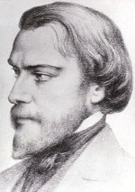Discussion: (Share your thoughts on the readings after a moment of silence)
How are we, in our Conference, living the spirit of Frederic?
Closing Prayer:
A Litany in Honor of Blessed Frederic Ozanam
Frederic Ozanam, defender of faith, pray for us.
Frederic Ozanam, promoter of hope, pray for us.
Frederic Ozanam, apostle of charity, pray for us.
Frederic Ozanam, exemplary husband and father, pray for us.
Frederic Ozanam, lover of poverty and the poor, pray for us.
Frederic Ozanam, advocate of the dignity of the human person, pray for us.
Frederic Ozanam, servant of the truth, pray for us.
Frederic Ozanam, model for Catholic teachers and professors, pray for us.
Frederic Ozanam, disciple of St. Vincent De Paul, pray for us.
Frederic Ozanam, faithful son of the Church, pray for us.
Frederic Ozanam, our intercessor at the throne of God, pray for us.
Amen

FEAST OF THE EXALTATION OF THE CROSS
September 14, 2025
Gospel: (John 3:13-17)
Jesus said to Nicodemus: "No one has gone up to heaven except the one who has come down from heaven, the Son of Man. And just as Moses lifted up the serpent in the desert, so must the Son of Man be lifted up, so that everyone who believes in him may have eternal life."
For God so loved the world that he gave his only Son, so that everyone who believes in him might not perish but might have eternal life. For God did not send his Son into the world to condemn the world, but that the world might be saved through him.
Reflection:
Jesus is the One raised up and by whom we are saved, we only must gaze on him and believe in him. The light of Christ enables us to see; seeing is believing. But we can only come to the light and believe if we “live in the truth” which is expressed in good works. Light and faith are gifts, and we demonstrate that we accept these gifts when we do good works. God demonstrates great love for us by sending the Son to be lifted up on the Cross and then raising him to eternal life. We demonstrate our great love for God by doing good works. Our good works: reaching out to others, doing our daily tasks for our family with love and care, working professionally and honestly, acting justly and charitably, then our way of being is “lifted up.” This is how we live in the truth, so that our works may be clearly seen as done in God. (Living Liturgy, p.90)
Vincentian Mediation:
In the Manual for the Society we read: On the occasion of the 250th anniversary of the canonization of St. Vincent de Paul, Pope John Paul II quoted the famous historian of Christian spirituality, Henri Bremond, about Vincent de Paul: “It was not love for men that led him to sanctity; rather it was sanctity that made him truly and effectively charitable; it was not the poor that gave him to God, but, on the contrary, God gave him to the poor.” God acts in the same way in the lives of all Vincentians. Holiness makes them truly and effectively charitable. It is God who gives them to the poor. (US Manual of the SVDP, p.50)
Discussion: (Share your thoughts after a moment of silence)
How have you found that it is “God who gave you to the poor”?
Closing Prayer:
Jesus, you urge us to take up our cross, and so we pray:
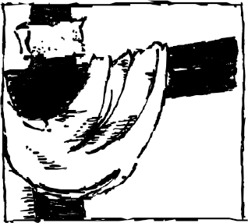

-Jesus, we turn to you.
For the grace to love life and faith into our families,
-Jesus, we turn to you.
For the grace to have “God send us to the poor,”
-Jesus, we turn to you. Amen

TWENTY-FIFTH SUNDAY IN ORDINARY TIME
September 21, 2025
Gospel: (Luke 16:1-13)
Jesus said to his disciples, “A rich man had a steward who was reported to him for squandering his property. He summoned him and said…’Prepare a full account of your stewardship, because you can no longer be my steward. The steward said to himself, ‘What shall I do?…I am not strong enough to dig and I am ashamed to beg….So he called in his master’s debtors one by one. To the first he said, ‘How much do you owe?’ He replied, ‘One hundred measures of olive oil.’ He said, ‘Here is your promissory note. Sit down and write fifty.’ Then to another who owed one hundred kors of wheat, he said “Here is your promissory note, write one for eighty.’ And the master commended that dishonest steward for acting prudently.
Reflection:
Prudent decisiveness that this gospel recommends means that we recognize that all our choices in daily living are really choices for eternal life. We honestly try to live good lives. When opportunities present themselves to act in a Christian way, most of us respond appropriately most of the time. This gospel challenges us to take this one step further. With an eye to the future, we must surrender ourselves to searching out opportunities to live the paschal mystery. There is such an urgency about discipleship that we cannot be passive in any way. Just as Jesus did all he needed to do to make his message known, so must we be as proactive in our own discipleship. (Living Liturgy, p.212)
Vincentian Meditation:
“Admission into heaven is something money cannot buy. The only currency that has any value to secure our entrance is that of love. In a world where so many things can be brought with money, often our minds center more on money than upon love. What Jesus is trying to tell us is that money is a good servant but a bad master. When money is employed as a servant, it can bring joy and comfort to millions and especially to those who have little or none of it. But let money become our master, let it take the first place in our lives and it can be a tyrant. It can harder our hearts and blind our vision of the supreme realities of our existence. Millions of dollars passed through the hands of St. Vincent and he made every cent a good servant. Vincent regarded the money which he received or possessed as the “patrimony of the poor,” and so it was always to be used for the benefit of the poor.” (McCullen, Deep Down Things,p. 560)
Discussion: (Share your thoughts after a moment of silence)
In what ways are we challenged to make our money a “true servant” not a master?
Closing Prayer:
Lord, as pilgrims on the journey,
may we travel together in charity and service.
Lord, as servants of the poor and one another,
may we reach out our hands in charity and service.
Lord, as we daily embrace the call to live in integrity,
may we reach out our hearts in charity and service.
Amen
FEAST OF ST. VINCENT de PAUL
September 27
Gospel: (Luke 4:16-19)
Jesus came to Nazareth where he had been reared, and entering the synagogue on the sabbath as he was in the habit of doing, he stood up to do the reading. When the book of the prophet Isaiah was handed him, he unrolled the scroll and found the passage where it was written: “The spirit of the Lord is upon me; therefore, he has anointed me. He has sent me to bring good tidings of joy to the poor, to proclaim liberty to captives, recovery of sight to the blind and release to prisoners, to announce a year of favor from the Lord.” Rolling up the scroll he gave it back to the assistant and sat down. All in the synagogue had their eyes fixed on him. Then he began by saying to them, “Today this Scripture passage is fulfilled in your hearing.”
Reflection:
“Vincent makes a clear explicit choice: ‘All aim at loving him, but they love him in different ways: Carthusians by solitude; Capuchins by poverty; others, again, by singing his praises. But we are bound to show it by leading the people to love God and their neighbor.’ The vision Vincent offers is not one of Christ as teacher, nor as healer, nor as “perfect adorer of the Father”( the vision of Berulle), nor “perfect image of the divinity” (the vision of Francis de Sales), but of Evangelizer of the poor. Vincent’s disciples are called to enter into the following of Christ in the very terms with which, in Luke’s gospel, Jesus opens his public ministry: ‘The Spirit of the Lord is upon me; therefore he has anointed me. He has sent me to bring glad tidings of joy to the poor…’ In Luke’s perspective, a new age is dawning. Jesus announces the good news of the kingdom to all, but especially to the poor, the weak, the lowly, the out casts of the world.” (Maloney, The Way of St. Vincent de Paul, p.22-23)
Vincentian Meditation:
“St. Vincent’s spirituality flows from his contemplation of this Christ. The driving force that generates both the incredible activity and the gentle contemplation of this great saint is his vision of the Evangelizer of the Poor. He encourages his followers to contemplate this Christ again and again. “O how happy they will be who can repeat at the hour of their death those beautiful words of Our Lord: ‘He sent me to bring good news to the poor.’”
(Maloney, The Way of St. Vincent de Paul, p.23-24)
Discussion: (Share your thoughts on the readings after a moment of silence)
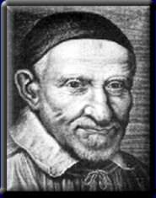In what ways do you “bring good news to the poor?”
Closing Prayer:
Gentle God, renew in us the spirit of our patron St. Vincent de Paul,
kindle is us the fire of your love.
Tender God, show us how to weep with those who weep,
fill our hearts with compassion and love.
Creator God, you call women and men to be Vincentians,
give us eyes to see Christ in the broken and the poor.

Amen

TWENTY-SIXTH SUNDAY IN ORDINARY TIME
September 28, 2025
Gospel: (Luke 16:19-31)
Jesus said to the Pharisees: “There was a rich man who dressed in purple garments and fine linen and dined sumptuously each day. And lying at his door was a poor man Lazarus, covered with sores, who would gladly have eaten his fill of the scraps that fell from the rich man’s table. When the poor man died, he was carried away by angels to the bosom of Abraham. The rich man died and was buried, and from the netherworld, where he was in torment, he raised his eyes and saw Abraham far off and Lazarus at his side. And he cried out ‘Father Abraham, have pity on me. Send Lazarus to dip the tip of his finger in water and cool my tongue, for I am suffering torment in these flames.’ Abraham replied, ‘My child, remember that you received what was good during your lifetime while Lazarus likewise received what was bad; but now he is comforted here whereas you are tormented. He said, ‘Then I beg you, father, send him to my father’s house, for I have five brothers, so that he may warn them, lest they too come to this place of torment.’ But Abraham replied, ‘They have Moses and the prophets. Let them listen to them.’ He said, ‘Oh no, father Abraham, but if someone from the dead goes to them, they will repent.’ Then Abraham said, ‘If they will not listen to Moses and the prophets, neither will they be persuaded if someone should rise from the dead.”
Reflection:
The basic commandment is to love God and neighbor. There is such a scriptural insistence on taking care of the poor and needy because when all have their fill of the good gifts of God it is a sign of God’s care and presence, the in-breaking of God’s reign where no one will be in need. When we neglect to care for those in need we actually delay the coming of God’s kingdom. Listening to God’s word, has a double edge: we not only learn to live but also further God’s kingdom when we respond appropriately to what we hear. Listening is part of the decisiveness of discipleship. (Living Liturgy, p.216)
Vincentian Meditation:
“As followers of St. Vincent, we profess to have both an eye and a heart for the suffering poor. We profess and proclaim to show the effective compassion of Jesus Christ towards those who are Lazarus in today’s world. To have an eye and a heart of compassion for the poor is a grace of Jesus Christ. We cannot turn on the compassion of Jesus, as we would water from a tap. We must humbly ask that grace of compassion from Jesus Christ.”
(McCullen, Deep Down Things, p. 297)
Discussion: (Share your thoughts after a moment of silence)
What challenges do you hear in this Gospel ?
Closing Prayer:
Lord, give us the grace of compassion for the “Lazarus” in our life,
so that we may suffer with those who suffer.
Lord, give us the grace to hear the cries of the poor,
so that we may be a servant of the most oppressed.
Amen

REFERENCES:

Manual of the Society of St. Vincent de Paul in the United States, National Council of the United States, 2007 (rev. 2021)

Gibson, Audrey DC and Kieran Kneaves DC, Praying with Louise de Marillac, Saint Mary’s Press, Winona, Minnesota,1995.

Maloney, Robert CM.* Go! On the Missionary Spirituality of St. Vincent de Paul.
Available from: Vincentian Studies Institute, (1-773-325-4943).

McCullen, Richard CM.** Deep Down Things, New City Press, Hyde Park, New York 1995.

McKenna, Thomas CM. Praying with Vincent de Paul, Saint Mary’s Press, Winona, Minnesota, 1994.

Melito, Jack CM. Saint Vincent de Paul-Windows on His Vision.
Available from: Vincentian Studies Institute, (1-773-325-4943).

Ramson, Ronald CM. Praying with Frederic Ozanam, Saint Mary’s Press, Winona, Minnesota, 1998.

Zimmerman, Joyce Ann C.PP.S. et al. Living Liturgy, The Liturgical Press, Collegeville, Minnesota, 2003.

Clip Art: Liguori Publications, Faithware –Cycle C, Liguori, Missouri, 1997.

* Father Robert Maloney was born and raised in Brooklyn, New York. He was the Superior General of the Congregation of the Mission and the Daughters of Charity, and of the Vincentian Family from 1993-2005.

** Father Richard McCullen was the Superior General of the Congregation of the Mission and the Daughters of Charity, and of the Vincentian Family from 1980-1992. Currently he lives in Dublin, Ireland.

For further information, please contact:

Timothy P. Williams
Society of St. Vincent de Paul
66 Progress Parkway

St. Louis, MO 63043-3706
E-MAIL: twilliams@svdpusa.org

The Vincentian Weekly Reflections have been developed exclusively for use by the Society of St. Vincent de Paul and cannot be reproduced in any form without the expressed consent of the Society of St. Vincent de Paul.

