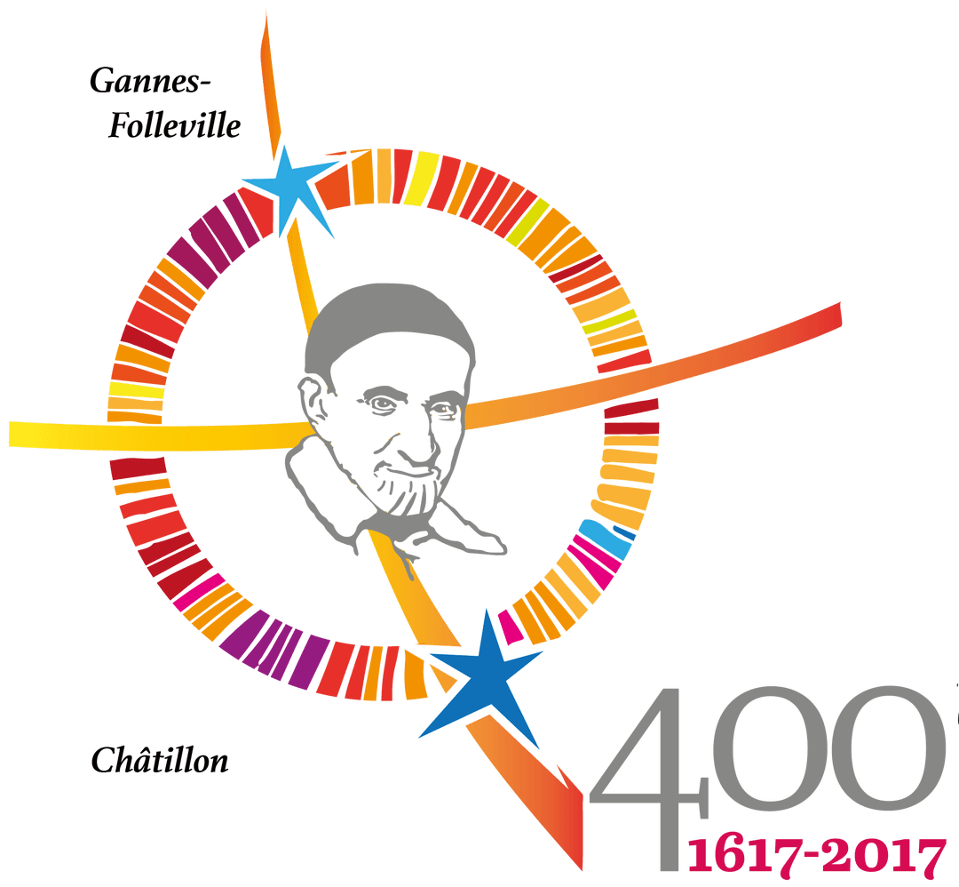

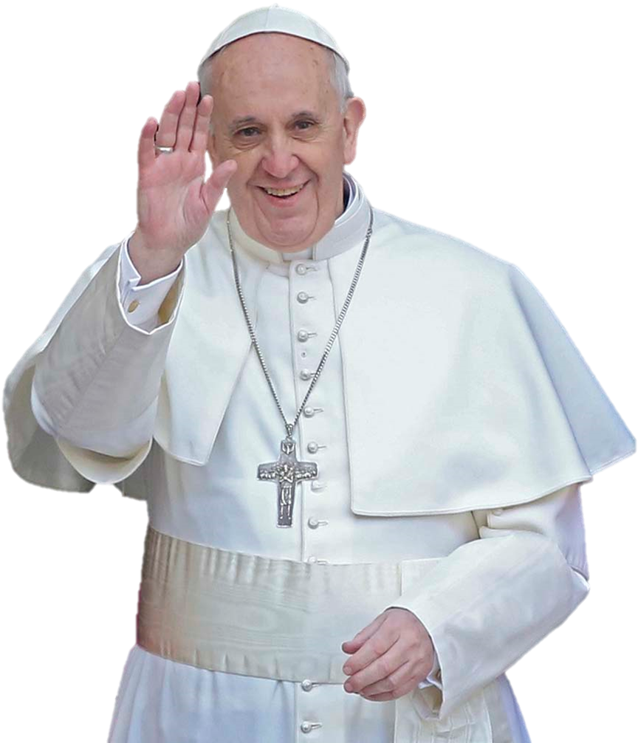

International Symposium of the Vincentian Family -http://famvin.org/en/2017/01/31/celebration-400th-anniversary-vincentian-charism/

;

Letter of Tomaž Mavrič, CM, President of the Vincentian Family Executive Committee
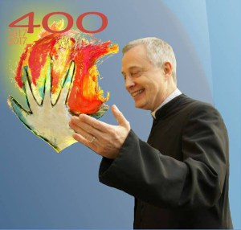

Dear Members of the Vincentian Family,
May the grace and peace of Jesus be always with us!
It is with great joy that I invite you to come to Rome on the weekend of 12 – 15 October 2017 for a Vincentian Family Symposium. Our Jubilee theme “Welcome the Stranger” is the focus of this event. The Symposium goes from Thursday (for registration only) through Sunday, 1:00 PM. Details for the Symposium are found on the Schedule.
I believe it is a gift from God to us to be able to celebrate this event together with Pope Francis, who will join us on Saturday, October 14. We are also privileged to have the reliquary with the Heart of St. Vincent, which has begun its journey throughout the world, with us in Rome for this weekend. It is a great blessing for the entire Vincentian Family and a beautiful opportunity for us to be renewed in our missionary zeal. We will also be celebrating a prayer vigil in the Basilica of St. Paul Outside the Walls, as well as the closing Mass on Sunday at St. Peter’s Basilica.
The 400th anniversary of the charism provides us with the perfect opportunity to celebrate our Vincentian heritage, to give thanks for all that has been done and to develop ideas and plans for the future. Of great importance is the consideration of our changing demographics and social contexts, the pressing needs of the poor, and our ability to best respond to these as a Family.
I also extend a special invitation to youth (ages 18-28). We hope that the Symposium will also be a powerful time to animate them in their Vincentian vocation.
After receiving the “Save the Date” announcement a few weeks ago, a number of people began to organize group travel and/or pilgrimages which would include the Symposium. I ask you to encourage your ministry groups – parishioners, schools and their alumni, etc. – as well as members of your volunteer groups, affiliates, and other collaborators – to think along these same lines.
On the Information Sheet are listed some travel agencies which may be able to assist you with housing and transportation. There is no registration fee for the Symposium. Each participant is responsible for the cost of his/her own travel, housing, and food.
We have also created this website through which you will be updated on the events which will occur over this weekend: http://famvin400.info/.
Please submit the registration form before 1 September, 2017. This helps us to finalize the logistics for offering the Symposium in six languages.
Please note: if your country requires you to obtain a Letter of Invitation in order to travel to Italy, please review the Information Sheet for instructions. Requests should be submitted from the request page by July 1, 2017.
I look forward to being with you soon in Rome!
Your brother in Saint Vincent de Paul
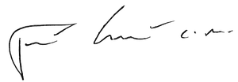
Tomaž Mavrič, CM
President, Vincentian Family Executive Committee

_________________________________________________________________________

