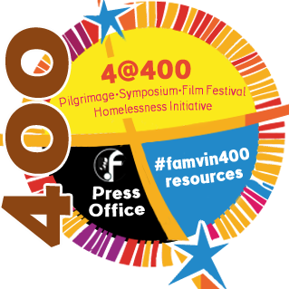
Schedule for Vincentian Symposium, Rome
We ask that you please plan to be present for the entire Symposium

Thursday, October 12:

9:00 AM – 9:00 PM (21:00): Registration at the Collegio Apostolico Leoniano; Via Pompeo Magno, 21; Rome (RM)

Friday, October 13:
- 9:00 AM: Conference and Panel Reflection on the theme
- 11:30 AM: Break and Lunch
- 4:00 PM (16:00): Conference and Opportunity for Questions and Answers
- 5:45 PM (17:45): Celebration of the Eucharist
- Evening Free

Saturday, October 14:
- Celebration of the Eucharist in private
- 8:30 AM: Paul VI Auditorium (at the Vatican) opens
- 9:30 AM: Symposium Program begins
- 11:30 AM: Session with Pope Francis; Break and Lunch
- 4 – 5:30PM (16:00 – 17:30): Conference/ Opportunity for Questions and Answers
- 8:30 PM (20:30): Prayer Vigil at the Basilica of St. Paul outside the Walls

Sunday, October 15:
- 8:30 AM: St. Peter’s Basilica opens
- 10:30 AM: Celebration of the Eucharist in St. Peter’s Basilica

CELEBRATION OF THE EUCHARIST: Priests are requested to bring their own albs and stoles for the celebrations of the Eucharist during the Symposium.
Please remember: all meals are on your own.
Further details will be provided as registrations are finalized.

