Indian Students
Scholarships

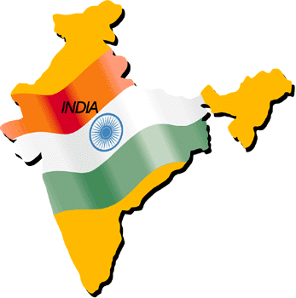

Information

and

Application Form

Society of St Vincent de Paul (Scotland)
Registered Office: 113 West Regent Street, Glasgow, G2 2RU
Registered Charity SC006326

Application to Sponsor an Indian Student
(Block Capitals and Dark Ink only please)

Conference Name:
Town:
Group Council
Diocesan Council
Contact’s Name:
Contact’s Address

I/We wish to sponsor _____ Vocational student(s) at a cost of £20 per student for the one year course.

I/We wish to sponsor _____ Technical student(s) for three years at a cost of £105 in total (£35 per student yearly).

I/We wish to sponsor _____ Vidya Jothi student(s) at a cost of
£20 per school child yearly.

I/We wish to sponsor _____ Higher Educational student(s) for five years at a cost of £275 in total (£55 per student yearly).

Part Payment [ ] Paid In Full [ ] (Technical/HE Students Only)

Date: ………………………..

Conference President:

Indian Student Sponsorship Scheme

The purpose of this scheme is to help suitably qualified students to continue and finish their studies. Whatever subjects they choose, the successful conclusion of their studies means that they are much more capable of finding a job and earning a living. In this way they can support their families for the future. We now have four different schemes for sponsorship:-

Vocational: 1 year course for auxiliary nursing, plumbing, commercial/secretarial practice etc.

Technical: 3 year course for nursing and some types of engineering.

Vidya Jothi: Each Indian Conference has adopted at least one poor school child in their area who, without guidance, motivation and assistance, would be unlikely to receive an education. National Council of Scotland has supported this scheme since 2004 but it is now open to Conferences.

Higher Educational: This new scholarship scheme helps engineering and medical students not covered by the Technical scheme. Their courses normally run for 5 years and involve huge costs for the students and their families.

Details of the sponsored student, including the course being studied, are given to the sponsor, generally on completion of their course. This takes the form of a ‘certificate’ each year, giving details of the progression through the course, which can be used for display purposes if desired. It is not possible to ‘match’ a particular student to a Conference in Scotland.

While the Sponsor can choose to sponsor either Technical or Vocational Students, they cannot specify the area of study for their supported student.

In the case of Technical and HE Students, while the sponsorship may be paid in one sum, it may also be paid annually, thereby spreading the cost over the three or five year period accordingly.
Please make ALL cheques payable to “SSVP Scotland”.
Other Aspects of Twinning

Twinning involves a commitment to a Conference overseas, which includes regular prayer, some correspondence and financial support to a Conference overseas. Please ask either you’re the National Twinning Representative or the National Office for more details.

Projects the former system of funding twinning projects has been totally changed. Previously a project from an Indian Conference which had been recommended by the National Council of India was sent to the twinned Scottish Conference, requesting that they help to fund the particular project. However, often it was left to our National Council to fund these projects which, due to financial restraints, is no longer possible. It was decided to set up a Project Fund to which every Conference in Scotland could contribute and when enough money had been donated by the Conferences to this fund, it would allow us then to consider the funding of these projects. In other words, if sufficient donations are not provided by the Scottish Conferences, NO projects can be funded! If a Conference decides to offer a donation to the Project fund, all it needs to do is send a cheque to the National Office for the amount donated, indicating on the back of the cheque that it is for the Project Fund.

Disaster Fund is designed to meet the immediate needs of the poor ANYWHERE when a disaster of any kind strikes. Almost as soon as it has reached the news, it is likely that a donation is on its way to the National Council of the affected country. This money will be used to buy items that are needed to alleviate the immediate suffering or to help with the long-term aid of those affected when immediate International Aid ceases.

For more information contact the National Twinning Officer or the National Office.

